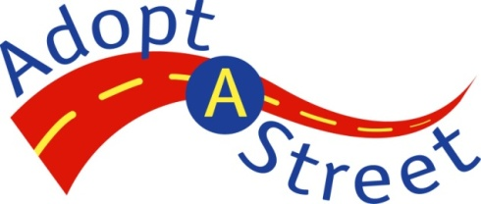
Supply Request Form

Follow these three steps to request supplies for your Adopt-A-Street cleanup event! Please complete and submit your supply request at least two weeks prior to your scheduled event to allow time to fill your order.

If cleaning up in public spaces, please remember to be respectful of persons experiencing homelessness and to leave camps and personal property items in place. Be mindful of personal safety and do not clean within 20 feet of tents and encampments. To report camping on City property, contact the Customer Service Bureau (CSB) via webform at http://seattle.gov/customerservice/ or telephone at 206-684-CITY (2489).

Information provided to Seattle Public Utilities is considered a public record and may be subject to public disclosure. For more information, see the Public Records Act, RCW Chapter 42.56.

Note: It is the sole responsibility of the Adopt-A-Street volunteer to arrange for the return of supplies to the City of Seattle’s Adopt-A-Street program. Possession of City government property beyond agreed-upon terms is unlawful. PLEASE PRINT LEGIBLY.

Step 1. List Contact Information for the Cleanup Event Organizer
First and last name: | Name of volunteer group or organization:
Phone number: | Email address:
Today’s date: | Date of cleanup event:

Step 2. Indicate Exact Number of Supplies You Need
PLEASE DISPOSE OF THE FOLLOWING ITEMS AFTER USE:
How many of each?
Canvas gloves: (Keep used gloves) Small Large | Latex gloves: (Keep used gloves)
Plastic garbage bags: (Dispose of non-recyclable and non-compostable litter) | Compostable paper bags:  (Dispose of compostable street debris and leaves)
Sharps containers: (Limit one per volunteer group.)
Note: Sharps containers must be disposed of at the City’s Recycling& Disposal Stations are located at 1350 N 34th St and 8105 5th Ave S.

TO REQUEST PAINTING SUPPLIES, YOU MUST BE SIGNED UP AS A GRAFFIT VOLUNTEER:
Paint Rollers: Small Large | Gray Paint: Brown Paint:  (Paint comes in five gallon buckets)

PLEASE RETURN THE FOLLOWING ITEMS AFTER USE:
Litter grabbers: | Safety vests: | Storm drain stencil kit: (Limit one per volunteer group.)

Step 3. Report Every Cleanup
Even if you do not require a litter pick-up, always report your cleanup event once it has ended by calling the hotline at 206-684-7647 or sending us an email at the address listed below. Let us know the following:

- Your name and phone number
- Date of cleanup
- Number of hours spent on the cleanup
- Number of volunteers who participated
- Number of bags
- The location and picture of the bags, if there are two or more (only if pick up is need

