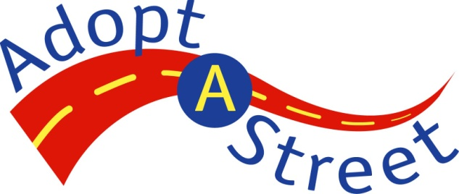Adopt-A-Street Program Volunteer Application Form

Sign up to volunteer! Just follow these five easy steps to apply to volunteer with the Adopt-A-Street program.

Step 1: Provide your contact information

First and last name of primary contact person: | Phone number of primary contact person:
Name of volunteer group, organization, or business: | Email address of primary contact person:
Address: | Name of secondary contact person:
City, state, and ZIP code: | Phone of secondary contact person:

Step 2: Choose which option is right for you (select only one of the following options)

Traditional Adopter: At least 1 mile of city streets, and 4 cleanups per year for 2 years*: Along with Adopt-A-Street supplies, individuals and/or groups that select and fulfill this option can choose to receive one official Adopt-A-Street street sign in recognition of their cleanup efforts. Complete an Adopt-A-Street Sign Request Form (doc) to request the sign.

*Note: Participating businesses must adopt arterials, i.e. moderate - to high-capacity roads.

Special Adopter: No street length or number of cleanups required. Individuals and/or groups receive Adopt-A-Street supplies for cleanup events.

Step 3: Indicate the streets you would like to adopt

List the streets you are adopting by specifying their exact location and zip code(s). For example: S Jackson St between Alaskan Way and 14th Ave S, 98104 and 98144. If possible, attach a map indicating desired route.

Street Segments:
Zip code:

Step 4: Tell us how you learned about the Adopt-A-Street program

How did you first learn about the Adopt-A-Street program? (Check the appropriate box.)

Word-of-mouth
Adopt-A-Street website
Adopt-A-Street brochure
Adopt-A-Street newsletter
Adopt-A-Street neighborhood flyer
Clean and Green event
Other (Specify):

Volunteer Application Form for the Adopt-A-Street Program, page 2

Step 5: Read and sign the volunteer agreement

Volunteer Agreement
As the designated primary contact person for my Adopt-A-Street volunteer group, I agree to:

- Contact the Adopt-A-Street Coordinator at least two weeks prior to the cleanup event in order to request supplies or coordinate your event. The Coordinator can be reached at 206-684-7647 or AdoptaStreet@Seattle.gov.

- Assure that volunteers are not using City of Seattle owned Adopt-A-Street supplies or resources for business reasons or for the purposes of monetary compensation.

- Assure that all volunteers are responsible individuals and that participating minors under the age of 18 are provided with adult supervision.

- Request that volunteers sign-in for each cleanup using the Adopt-A-Street Volunteer Sign-In Sheet.

- Discuss safety precautions with volunteers using the Adopt-A-Street Safety First Guidelines. Volunteers should avoid contact with items that have the potential to be hazardous or cause injury, such as heavy objects or syringes, needles, used condoms, animal carcasses, etc.

- Report all cleanups—whether you need a bags picked-up or not—to the Adopt-A-Street hotline at 206-684-7647 or via email at AdoptaStreet@Seattle.gov. In your message, please tell us 1) your name and phone number, 2) name of your organization, 3) number of hours spent on the cleanup, 4) number of volunteers who participated, 5) number of bags, and 6) the location of the bags, if you have two or more full bags you need picked up. Bags must be left on public property.

- Assure that all borrowed equipment and unused supplies are returned to the Adopt-A-Street Program upon completion of each cleanup event or the duration of your volunteer service.

- Assure that all volunteers are physically able to perform cleanup tasks.

City of Seattle Agreement
The City of Seattle agrees to:

- Furnish operation supplies such as plastic litter bags and gloves, and maintain a limited supply of equipment and tools for loan.

- Coordinate the removal and disposal of two of more full bags of collected litter and/or compostable street debris and leaves from the project site at no cost to volunteers.
- Provide insurance for authorized volunteers for on-the-job injury and property damage liability occurring within the course and scope of the project.

I have read and reviewed this agreement and agree to fulfill the terms of participation outlined for Adopt-A-Street volunteers. Signed,

Signature of primary contact person and date

Graffiti - Check here if you would like someone to follow up with you about graffiti issues.

Return completed form to AdoptAStreet@Seattle.gov or AdoptADrain@Seattle.gov, or fax to 206-684-8529.
Questions? Call the Adopt-A-Street/Adopt-a-Drain Hotline at 206-684-7647.
http://www.seattle.gov/util/Services/Garbage/KeepSeattleClean/Adopt-A-Street/index.asp

