M E M O R A N D U M

Date: April 16, 2019
To: Board of Park Commissioners
From: Joelle Hammerstad, Sustainable Operations Manager
Karen Galt, Water Management Coordinator
Subject: Update on Water Use at Seattle Parks & Recreation

Requested Board Action
The purpose of this briefing is to update the Board of Park Commissioners on water management at Seattle Parks & Recreation (SPR). No Board action is required.

Project or Policy Description and Background
For the past 13 years, SPR has closely monitored our water use. With this data, we’ve been able to build a robust understanding of the department’s water consumption needs.

Water use and cost portfolio
A little more than three-quarters of our water consumption is irrigation. SPR irrigates from around mid-May to mid-September, depending on the weather.
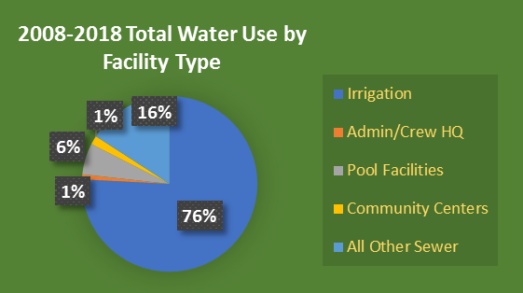
Of the 6,500 acres SPR manages, a little less than 10% (about 600 acres) is irrigated. Most of our irrigation systems use drinking water.

In the past 10 years, our operational costs for water consumption have doubled – due to rate increases. And rates continue to rise. In 2019, Seattle Public Utilities will increase water rates by 5.8 percent over 2018 rates. Capital funding remains a challenge as well. With the funding currently available, we can replace existing irrigation systems once about every 48 years.

Using technology to support smarter water use
About three-quarters of our irrigation use is managed by a smart irrigation control system called Maxicom. Maxicom uses real-time weather data to control irrigation. It employs cellular modem technology to communicate with weather stations, and allows us to manage the system remotely.

In addition, we have created a new ArcGIS Collector app for smart phones that allows plumbers, electricians and gardeners to locate assets in the field. As staff visit irrigation systems for maintenance, they can input the exact location of controllers, rain sensors, valves, meters and other infrastructure. This saves time the next time plumbers are called to the site. They can call up the “crowd-sourced” infrastructure data on their smartphones and instantly know where all parts of a system are located. This reduces response time and saves water.

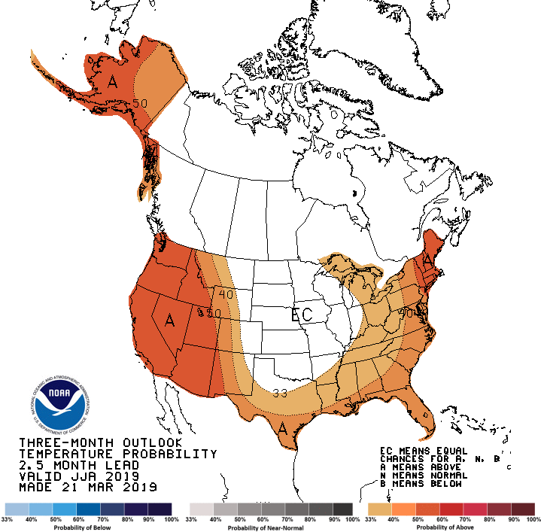
What about this summer? Supply & Demand
SPR relies on Seattle Public Utilities’ water reservoirs to provide the lion’s share of our water needs. As such, we closely monitor their public website for weekly updates on water supply forecasts. While snow pack remains about one-third below the long-term average (1981 – 2010), the utility does not anticipate any supply problems this summer.

SPR also begins to forecast our own water needs based on the historical averages needed to maintain healthy living assets. We are seeing that the ground moisture conditions are beginning to dry, that summer temperatures are expected to be above normal and that a typical summer rain is forecast for the summer months.
National Oceanic and Atmospheric Administration June, July, August long-range temperature forecast

Climate Change + Water Costs = Adaptation
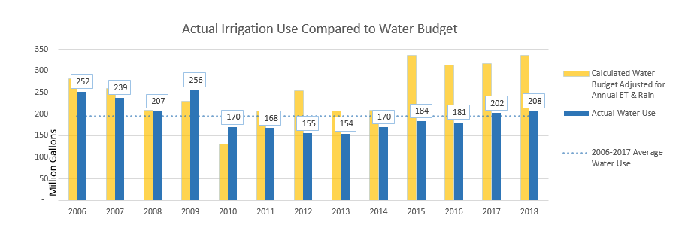
As our summers get longer, hotter and drier, so does our need for more irrigation. The amount of water required to keep our living assets in good condition jumped significantly in 2015 during the worst drought in Washington state history. Our irrigation need has remained high since.
“Water Budget” refers to the amount of water consumption that should be needed to support the optimal health of our living assets.

During the 2015 drought, SPU issued water use restrictions to ensure that the region would have enough water to make it through to the end of the drought. SPR used the opportunity to take lessons learned from that event to update our Water Shortage Contingency Plan. It now includes clear graphics, specific direction on best practices and suggested public messaging.

Understanding that the climate is changing, and that SPR will always have a need to support the health and safety of our living assets, the department will undertake a water re-use study this year. Since nearly all of our irrigation uses drinking water, this study will help us identify other sources of non-potable water that can be used for this purpose. Not only will this reduce operational costs in the future, it will also make our landscapes more sustainable and our department more resilient.

