How to create a digital signature:
- Click on the form you want to download.
- Click on the purple icon on the right labeled “Fill & Sign.”
Fill out the form until you need to sign the form.
- At the top in the middle, click on the image of a fountain pen.
  - Click “Add Signature”
  - Options given to type, draw or download an image of your signature.
    - Type = Auto script of your signature with options to change the style
    - Draw = draw your own
    - Image = If you already have an image of your signature in your computer files
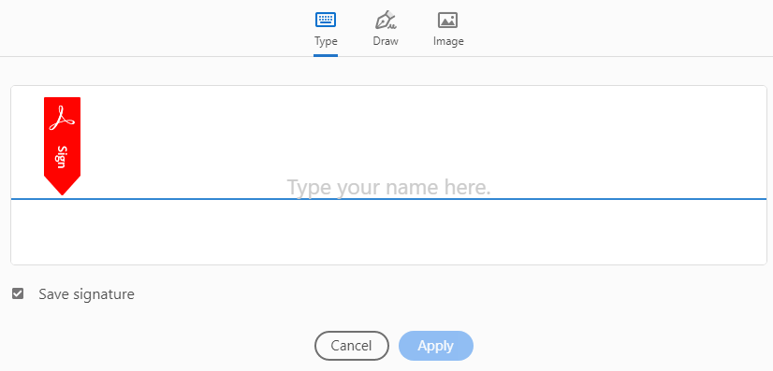
- Click “Apply” when finished.

