**Skagit River Hydroelectric Project (#553)**

**Erosion Control and Revegetation Completion Report 2014-15**

**J. Riedel, Geologist, North Cascades National Park**

**Stacy McDonough, Horticulturalist, North Cascades National Park**

**INTRODUCTION**

As stipulated in the 1991 Erosion Control Settlement Agreement (SA) between the National Park Service (NPS) and Seattle City Light (City Light), erosion control activities in Ross Lake National Recreation Area (NRA) continued during the two-year period of 2014-2015. The purpose of this report is to update the Federal Energy Regulatory Commission (FERC) on progress under the terms of the operating license for the Skagit River Hydroelectric Project (Project). Detailed accounting of expenditures in this report is not provided because this information is provided in other reports.

A total of 25 recreation sites, including docks, campgrounds and trails have been treated in the past 25 years. The combined area of stabilized shoreline is nearly 1/3 mile in a difficult setting with steep slopes, where the average erosion rate in unconsolidated glacial deposits is 1 ft/year, and can exceed 5 ft/year (Riedel 1990).

NPS crews, funded by City Light, conducted work at several sites in 2014-2015. After 25 years of building large erosion control structures, the emphasis has now shifted to maintenance of this inventory. In the past two years NPS has also continued to monitor the rate of erosion at several unprotected sites.

**SITE MAINTENANCE**

All 25 sites previously treated are in good to excellent condition. Maintenance of the rock walls mainly entails rebuilding the toe scour protection, where most wave energy is focused when the lake is at or near full pool. Work crews rebuilt toe scour protection for structures at sites E97 (McMillan Camp), E95 (May Creek Camp), E118 (Lightning Camp), and W125 (Little Beaver Camp). Toe protection was also maintained at a cultural site.

At site E-134A (Cat Island Camp) several additional large logs were added each year to a wood structure at the west end of the site (Figure 1).

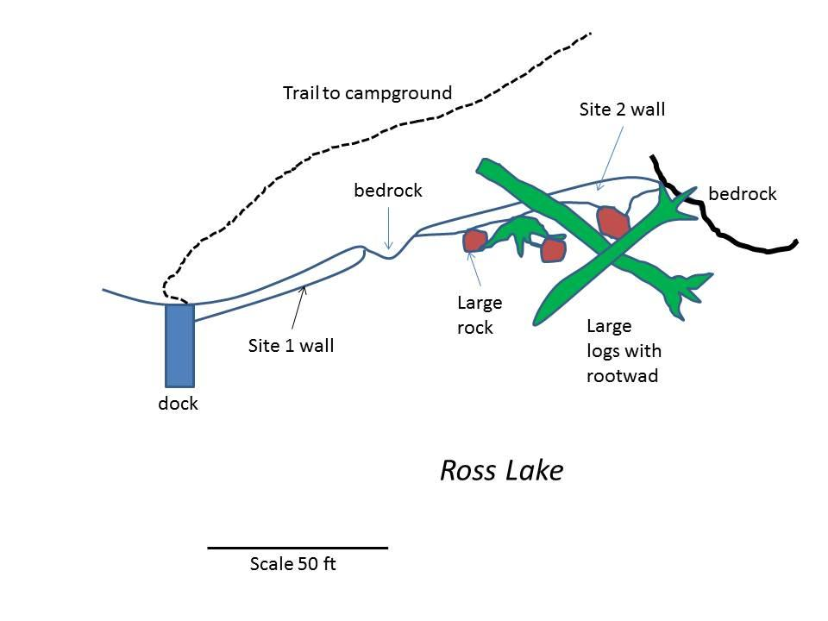

**Figure 1.** Conceptual design of the rock wall and log structure added in 2014-2015 at Cat Island, Site E-134A.

**PLANT PROPAGATION**

**2014**

* All erosion control sites were visited and reviewed to determine needs for seed collection and plant propagation.
* Maintained 5876 plants in Marblemount nursery.
* Completed plantings of 1619 plants at Big Beaver, Ten Mile Island, Dry Creek and Cat Island (Table 1; Figures 2-5).
* Sowed 8.26 oz of seed collected between 2006 and 2014 for four erosion control sites (Table 2).



Figure 3. Cat Island Site 01 Planting



Figure 4. Ten Mile Island Site 03 Planting 2014

Figure 5. Ten Mile Island Site 01 Planting 2014

Figure 2. Cat Island Planting

| **Table 1.** 2014Plantings | | | |
| --- | --- | --- | --- |
| **Species** | **Common Name** | **# Planted** | **Notes** |
| ***Cat Island – Site 01*** | | | **Erosion Control Wall** |
| *Achillea millefolium* | Yarrow | 31 |  |
| *Arctostaphylus uva-ursi* | Kinnickinnick | 43 |  |
| *Berberis aquifolium* | Tall Oregon Grape | 49 |
| *Berberis nervosa* | Dull Oregon Grape | 137 |  |
| *Elymus glaucus* | Blue Wild Rye | 7 |  |
| ***Cat Island – Site 02*** |  |  | **Above timber wall adjacent to boat dock** |
| *Danthonia intermedia* | Timber Oat Grass | 7 |  |
| ***Cat Island - Site 03*** |  |  | **Switchback cut up to trail to camp**. |
| *Arctostaphylus uva-ursi* | Kinnickinnick | 6 |  |
| *Berberis nervosa* | Dull Oregon Grape | 6 |  |
| ***Cat Island 04*** |  |  | **Eroded slope south of erosion control wall** |
| *Acer circinatum/glabrum* | Vine and Douglas Maple | 48 |  |
| **Cat Island TOTAL** |  | **334** |  |
| ***Ten Mile Island - Site 01*** |  |  | ***Erosion Control Wall NW of Camp Site 3***. |
| *Berberis aquifolium* | Tall Oregon Grape | 52 |  |
| *Arctostaphylus uva-ursi* | Kinnickinnick | 20 |  |
| ***Ten Mile Island Site 02*** |  |  | ***Erosion Control Wall NE of Camp Site 3***. |
| *Acer circinatum* | Vine Maple | 8 |  |
| *Acer glabrum* | Douglas Maple | 5 |  |
| *Berberis aquifolium* | Tall Oregon Grape | 48 |  |
| *Arctostaphylus uva-ursi* | Kinnickinnick | 31 |  |
| ***Ten Mile Island Site 03*** |  |  | **Planting Near camp site 1. Area is up slope of the trail which runs along the lakeshore**. |
| *Berberis nervosa* | Dull Oregon Grape | 40 |  |
| ***Ten Mile Island Site 04*** |  |  | **Planting down slope of the trail at Site 03. This planting consists of wetland species**. |
| *Carex sp.* | Sedges | 200 |  |
| *Juncus sp.* | Rushes | 200 |  |
| ***Ten Mile Island Site 05*** |  |  | **Planting was completed between camp ites 1 and 2** |
| *Acer circinatum* | Vine Maple | 8 |  |
| *Acer glabrum* | Douglas Maple | 8 |  |
| *Amelanchier alnifolia* | Juneberry | 12 |  |
| *Arctostaphylus uva-ursi* | Kinnickinnick | 20 |  |
| ***Ten Mile Island Site 06*** |  |  | **Planting upslope from camp site 1.** |
| *Acer circinatum* | Vine Maple | 25 |  |
| *Acer glabrum* | Douglas Maple | 11 |  |
|  |  | **36** |  |
| **Ten Mile TOTAL** |  | **688** |  |
| **Big Beaver TOTAL** |  | **509** |  |
| **Dry Creek TOTAL** |  | **88** |  |
| **TOTAL 2014 Plant Installations** |  | **1619** |  |

|  |  |  |  |
| --- | --- | --- | --- |
| **Table 2.** 2014 Seed Sown | | | |
| **Project** | **Collection #** | **Species** | **Ounces Sown** |
| Big Beaver | 2011 | *Carex lenticularis* | 0.15 |
| Big Beaver | 2011 | *Carex mertensiana* | 0.05 |
| Big Beaver | 2011 | *Carex rostrata* | 0.01 |
| Big Beaver | 2011 | *Juncus ensifolius* | 0.05 |
|  |  | **Project Total** | **0.26** |
| Cat Island | 2008 | *Danthoia spicata* | 0.60 |
| Cat Island | 2008 | *Festuca idahoensis* | 0.10 |
| Cat Island | 2007 | *Berberis nervosa* | 0.35 |
| Cat Island | 2006 | *Achillea millefoium* | 0.60 |
| Cat Island | 2006 | *Elymus glaucus* | 0.05 |
| Cat Island | 2006 | *Festuca idahoensis* | 0.15 |
| Cat Island | 2006 | *Festuca sp* | 0.05 |
|  |  | **Project Total** | **1.90** |
| Dry Creek | multiple | *Carex sp* | 4.10 |
| Dry Creek | Multiple | *Juncus sp* | 1.00 |
| Dry Creek | Multiple | *Hordeum jubatum* | 0.10 |
| Dry Creek | 2009 | *Calamagrostis sp* | 0.10 |
|  |  | **Project Total** | **5.30** |
| Ten Mile Island | 2012 | Arctostaphylus uva-ursi | 0.45 |
| Ten Mile Island | 2009 | Amelanchier alnifolia | 0.05 |
| Ten Mile Island | 2009 | Festuca idahoensis | 0.30 |
|  |  | **Project Total** | **0.80** |
| **TOTAL 2014 Plant Seed Sown** | | | **8.26** |

**2015**

* Maintained plant collections in native plant nursery for all erosion control sites.
* Watered 2014 plant installations at Cat and 10 Mile Islands.
* Completed report writing and creation of GPS and photo documentation logs.
* Completed site monitoring for 2014 plant installations.
  + **Cat Island** - overall survival rates between 25-90% for all 4 sites planted. Site 03 performed the poorest with <25% survival and sites 01 and 02 performed the best with approximately 80-90% survival.
  + **Ten Mile Island** - Overall survival rates between 25-50% for all 6 sites. Site 05 performed the poorest with <25% survival and sites 03 and 04 performed the best with greater than 50% survival.
* Transplanted 4,439 seedlings from seed sown in 2014 for future plantings at Ross Lake Erosion Control Site (Table 3).
* Completed plantings at Big Beaver and Dry Creek, installing 1400 plants (Table 4).
* Sowed 2.5 oz of seed for target plant production of 2100 plants (Table 5).

|  |  |  |  |  |
| --- | --- | --- | --- | --- |
| **Table 3.** 2015 Seedlings Transplante**d** | | | | |
| **Project** | **Collection Number** | **Species** | **Common Name** | **Total Plants Transplanted** |
| Big Beaver | 2011 | *Carex lentiularis* | Goosegrass Sedge | 27 |
|  | 2011 | *Carex mertensiana* | Mertens's Sedge | 180 |
|  | 2011 | *Carex rosii* | Ross's Carex | 113 |
| Cat Island | *2008* | *Danthonia spicata* | Timber Oat Grass | 108 |
|  | *2006* | *Elymus glaucus* | Blue Wild Rye | 54 |
| Dry Creek | *2008* | *Juncus ensifolius* | Swordleaf Rush | 108 |
|  | *2009* | *Juncus ensifolius* | Swordleaf Rush | 24 |
|  | *2009* | *Juncus effusus* |  | 1,035 |
|  | *2009* | *Carex kelloggii* | Kellogg's Sedge | 46 |
|  | *2014-014* | *Carex lenticularis* | Lakeshore Sedge | 1,224 |
|  | *2008* | *Carex rostrata* | Beaked Sedge | 32 |
|  | *2010* | *Carex rostrata* | Beaked Sedge | 27 |
|  | *2011* | *Carex rostrata* | Beaked Sedge | 33 |
|  | *2007* | *Carex sitchensis* | Sitka Sedge | 3 |
|  | *2008* | *Carex sitchensis* | Sitka Sedge | 6 |
|  | *2009* | *Carex sitchensis* | Sitka Sedge | 88 |
|  | *2011* | *Carex sitchensis* | Sitka Sedge | 39 |
|  | *2014-005* | *Carex vesicaria* | Bladder Sedge | 948 |
|  | *2014-043* | *Carex sp* | Sedge | 11 |
|  | *2014-041* | *Carex sp* | Sedge | 328 |
| Ten Mile Island | *2009* | *Amelanchier alnifolia* | June Berry | 5 |
|  |  |  | **TOTAL** | **4,439** |

|  |  |  |  |
| --- | --- | --- | --- |
| **Table 4.** 2015 Plant Installations | | | |
| **Species** | **Common Name** | **# Planted** |  |
| ***Big Beaver*** | | |  |
| *Carex sp* | Sedges | 508 |  |
|  |  |  |  |
| ***Dry Creek*** |  |  |  |
| *Carex sp* | Sedges | 896 |  |
|  |  |  |  |
| **2015 TOTAL** |  | **1404** |  |

|  |  |  |  |
| --- | --- | --- | --- |
| **Table 5.** 2015 Seed Sown | | | |
| **Project** | **Collection #** | **Species** | **Ounces Sown** |
| Ten Mile Island | 2015-033 | Carex sp | 0.15 |
|  | 2009 | Calamagrostis rubescens | 0.10 |
|  | 2007 | Prunus emarginata | 0.40 |
|  |  | **Project Total** | **0.65** |
| Cat Island | 2015-042 | Antennaria lanata | 0.01 |
|  | 2015-043 | Elymus glaucus | 0.01 |
|  | 2006 | Elymus glaucus | 0.45 |
|  | 2015-045 | Achillea millefoium | 0.15 |
|  | 2015-046 | Calamagrostis rubescens | 0.01 |
|  | 2009 | Calamagrostis rubescens | 1.00 |
|  | 2015-057 | Berberis sp. | 0.05 |
|  | 214 | Acer circinatum | 0.15 |
|  |  | **Project Total** | 1.83 |
| **TOTAL 2014 Plant Seed Sown** | | | **2.48** |

**SEED COLLECTION**

**2014 -** Collected a total of 22.75 oz seed for propagation in 2014 and subsequent years.

| **Project Site** | **Species Code** | **Weight in oz.** | **Collection Number** |
| --- | --- | --- | --- |
| **Cat IslandCacata Cat Island** | *Acer circinatum* | 0.15 | 2014-040 |
| **Devil's Creek** | *Berberis nervosa* | *0.20* | 2014-031 |
| **Dry Creek** | *Carex len.* | 7.40 | 2014-004 |
| **Dry Creek** | *Carex ves.* | 0.70 | 2014-005 |
| **Dry Creek** | *Carex len.* | 0.90 | 2014-041 |
| **Dry Creek** | *Carex sp.* | 1.05 | 2014-043 |
| **Dry Creek** | *Carex sp.* | 0.40 | 2014-044 |
| **Dry Creek** | *Juncus sp* | 0.05 | 2014-046 |
| **Dry Creek** | *Carex sp.* | 0.70 | 2014-048 |
| **Dry Creek** | *Carex sp.* | 0.10 | 2014-049 |
| **Dry Creek** | *Juncus eff.* | 10.10 | 2014-078 |
| **Lodgepole** | *Carex len.* | *0.10* | 2014-023 |
| **Lodgepole** | *Acer circinatum* | *0.05* | 2014-024 |
| **Lodgepole** | *Pinus contorta* | *0.05* | 2014-027 |
| **Lodgepole** | *Carex sp.* | *0.10* | 2014-030 |
| **Lodgepole** | *Berberis nervosa* | *0.55* | 2014-032 |
| **Lodgepole** | *Rosa gymnocarpa* | *0.05* | 2014-034 |
| **Lodgepole** | *Prunus emarginata* | *0.05* | 2014-035 |
| **Lodgepole** | *Carex sp.* | *0.05* | 2014-037 |
|  | **Total 2014** | **22.75** |  |

**2015 -** Collected a total of 15.88 oz seed for propagation in 2015 and subsequent years.

| **Project Site** | **Species Code** | **2015 Weight in oz** | **Collection Number** |
| --- | --- | --- | --- |
| **Cat Island** | *Antenaria lanata* | 0.01 | 2015-042 |
| **Cat Island** | *Elymus glaucus* | 0.01 | 2015-043 |
| **Cat Island** | *Pinus contorta* | 0.10 | 2015-044 |
| **Cat Island** | *Achellia millefolium* | 0.15 | 2015-045 |
| **Cat Island** | *Calamagrostis rubescens* | 0.01 | 2015-046 |
| **Cat Island** | *Berberis sp* | 0.05 | 2015-057 |
| **Cat Island** | *Arctostaphylus uvi-ursi* | 0.65 | 2015-058 |
| **Dry Creek** | *Cares/Juncus* | 1.60 | 2015-034 |
| **Dry Creek** | *Carex sp.* | 0.35 | 2015-035 |
| **Dry Creek** | *Carex sitchensis* | 7.30 | 2015-037 |
| **Dry Creek** | *Carex rostrata* | 0.70 | 2015-038 |
| **Dry Creek** | *Carex lenticularis* | 1.35 | 2015-039 |
| **Dry Creek** | *Juncus sp.* | 0.40 | 2015-040 |
| **Spencer Island** | *Carex sp.* | 2.45 | 2015-036 |
| **Ten Mile Island** | *Carex sp.* | 0.75 | 2015-033 |
|  | **Total 2015** | **15.88** |  |

**EQUIPMENT MAINTENANCE**

The final activity in 2014-15 was maintenance of the erosion control workboat known as ‘Sahale’. The Sahale has been the erosion control program boat for more than 17 years and is used to transport crews and materials to and from job sites and to push the barge and crane to project sites and material collection sites. The cables that control raising and lowering of the front gate were replaced in 2015.

**COMPLIANCE**

Copies of all permits are kept at the NPS office in Sedro-Woolley and are available on request.

**EROSION MONITORING**

NPS crews revisited a number of sites along Ross Lake in spring 2015 to measure rates of erosion along the reservoir shoreline, as identified in the Erosion Control Plan and Settlement Agreement (Figure 6). Each of the five sites monitored has a different rate of erosion because of varying bank material, aspect, and slope. The greatest total amount of bank recession is at three sites with thick glacial deposits (E9, E55, and W63), where erosion has claimed 14 to 18 feet of the bank in 21 years. Relatively low rates of erosion were observed at the other two sites. Site E99 is a rocky slope with colluvial soils, while site W78 has a shoreline composed of very dense glacial till. These results clearly identify the impact of the reservoir and underscore the need for bank protection to protect important recreational sites within the NRA.

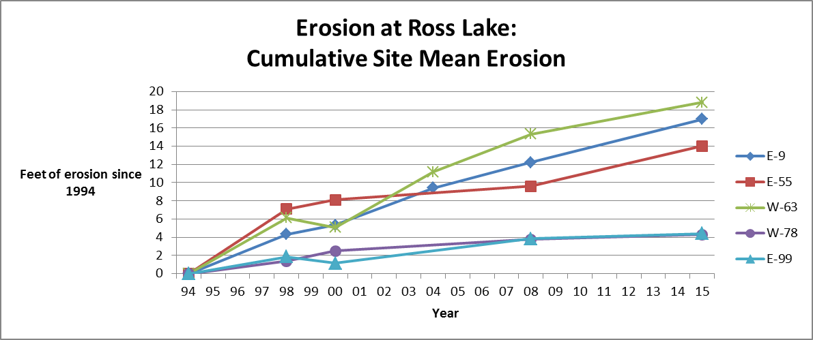

**Figure 6.** Total bank recession since 1994 at five sites on Ross Lake