SKAGIT - FERC PROJECT #553
EROSION CONTROL PROGRAM

2012-2013 COMPLETION REPORT

North Cascades National Park and Seattle City Light

May-2014
INTRODUCTION

As stipulated in the 1991 Erosion Control Settlement Agreement (SA) between the National Park Service (NPS) and Seattle City Light (SCL), erosion control activities in Ross Lake National Recreation Area (NRA) continued for year eighteen and nineteen (including pre-license work).

NPS crews funded by SCL conducted work at several sites in 2012 and 2013. In 2013, much of the time was spent moving large rock to work sites. In 2013, bank stabilization activity was focused on site E 134A at Cat Island, where bank erosion was 0.33 ft/year (Riedel, 1990; Figure 1). Other activities included maintenance of erosion control structures at several sites, and funds were also used to refurbish the main erosion control boat on Ross Lake. After 15 years of hauling crews and pushing the barge and crane the motor gave out in 2012 and was replaced in 2013 after a bidding process.

Detailed accounting of expenditures is provided in other reports and is not duplicated here. The purpose of this report is to update the Federal Energy Regulatory Commission (FERC) on progress under the terms of the operating license for the Skagit Project.

This period represents the 19th year of sustained erosion control activities in the Skagit Project since the first rock wall and revegetation project at Devils Junction Campground in 1991. In total, 25 recreation sites, including docks, campgrounds and trails have been treated. The combined area of shoreline stabilized is nearly 1/3 mile in a difficult setting with steep slopes, where the average erosion rate in unconsolidated glacial deposits is 1 foot/year, and can exceed 5 foot/year (Riedel, 1990).

PROGRESS REPORTS BY PROJECT-2012/2013

Erosion Control
Cat Island, Site E-134A (new site)
Unconsolidated sand and gravel glacial outwash on the north shore of Cat Island has been eroding rapidly since the late 1950s when Ross Reservoir was created. This erosion has isolated a dock bulkhead and has undermined part of the trail leading to the campground. The trail was relocated about 10 years ago (Figure 1), but continued bank retreat threatens the newer trail segment.

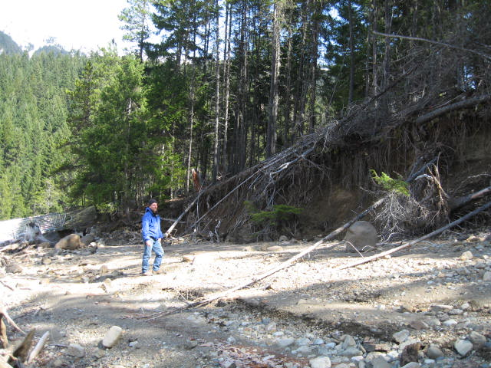
Figure 1. Cat Island site E-134A erosion control project before construction. Note dock at left.
The bank was stabilized by using an excavator to install a large rock and several logs at the east end of the site (Figure 2). To protect the dock bulkhead and campground trail, a 50-foot long x 5-foot tall rock wall was installed west of the dock bulkhead (Figures 2 and 3). Geotextile filter fabric and a graded soil filter were used in the wall to preclude sediment from filtering through the rock from behind the wall, causing wall failure. The toe of the wall was also buried 1.5 feet (1/2 design wave height) beneath the surface.
At the west end of the site, separated from the 50-foot wall, an irregular pattern of large rocks was placed at the toe of a steep eroding bank to slow erosion for 70 feet of bank. Large logs with root wads were anchored by these rocks to enhance habitat.
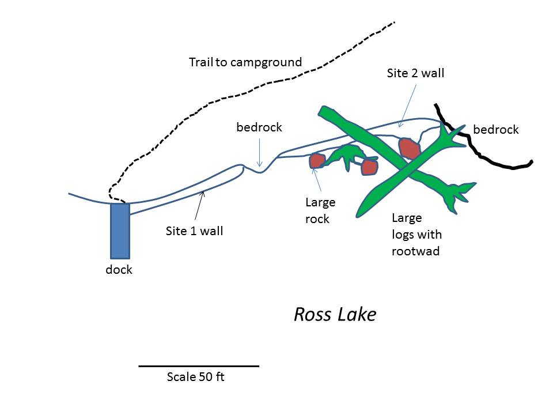
Figure 2. Conceptual design of rock wall and log structure built at Cat Island Island in 2013. Large wood will be supplemented with additional logs with root-wads as they become available.

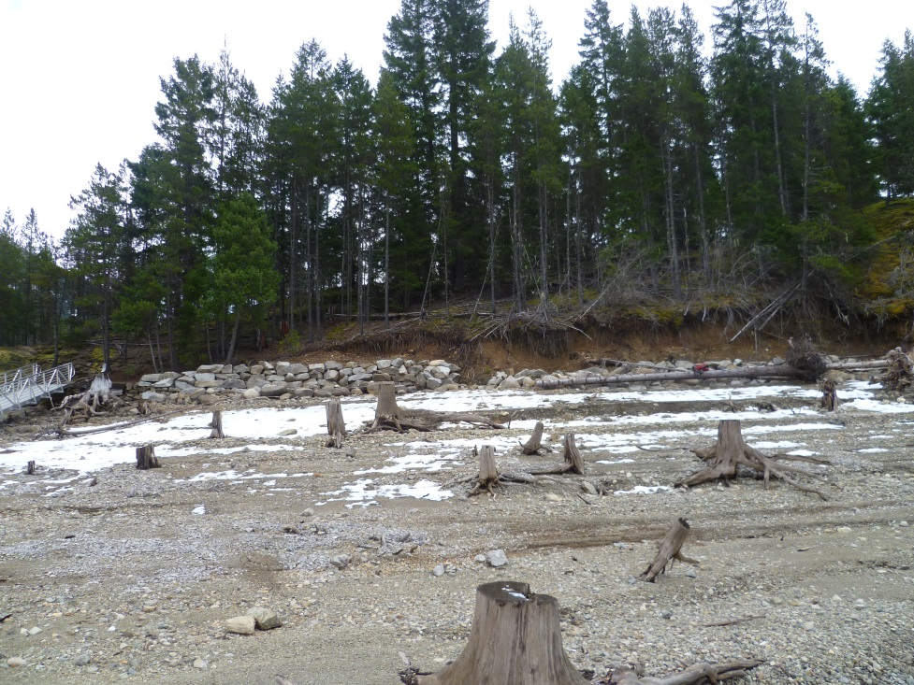
Figure 3. Final rock wall (at left) and logs with rock revetment at Cat Island.
Work at Other Sites
Erosion control structures built since 1991 were examined for failure and maintenance. All of the log crib and rock walls are in excellent shape, despite several that are more than 20 years old. The primary maintenance activity needed at a few of these sites included rebuilding of the scour protection apron at the toe of rock walls. This consisted of replacing hand-sized rocks that formed the apron.
Revegetation
Site E-134A will be revegetated in summer 2014 with native plants being grown in the greenhouse in Marblemount. The plant material was propagated from native seed and plant cuttings taken in 2012 and 2013 from nearby sites on Ross Lake.
Boat Motor
The final main activity in 2012-2013 was the purchase of a new motor for the former erosion control workboat that was known as ‘Sahale’. The Sahale has been the erosion control program boat for more than 15 years. This boat was used to transport crews and materials to and from job sites and to push the barge and crane to project sites and material collection sites. The boat engine failed in 2012 and was replaced and field tested in 2013. It is available to support maintenance activities in 2014.
Compliance
Permits from the U.S. Army Corps of Engineers (404 permit) and the State Department of Fish and Wildlife (hydraulic permit) were obtained before work began at site E-134. Copies of these permits are kept at the NPS office in Sedro-Woolley and are available on request.
Seed Collection
2012
24.3 ounces of seed was collected at the Lodgepole campground and Cat Island sites in conjunction with youth and volunteer groups. The collected seed was cleaned and stored or sown in the fall of 2012 to propagate plant materials for future plantings.

2013
Native plant seed was collected on Cat Island for use at the erosion control site on the north end of the island. Also, riparian plant seed was collected near Lodgepole campground for replanting the erosion control structure. The seed collected in 2013 will be used with the seed collected in previous years, and with plant stock on hand, to complete plantings at erosion control sites in 2014 (see Table 1).

Erosion Control Site | Scientific name | Common Name | Ounces of seed collected
Lodgepole | Carex spp. | Sedge | 0.50
Cat Island | Arctostaphylus uva-ursi | Kinnickinnick | 2.00
 | Pinus contorta | Lodgepole Pine | 0.10
Table 1. Ounces of seed collected per erosion control site in 2013.

Plant Propagation
2012
Seed collected in 2012 was sown in the fall of 2012 for both the Lodgepole and Cat Island erosion control sites.

Erosion Control Site | Scientific name | Common Name | Number of seed flats sown
Lodgepole | Berberis nervosa | Oregon Grape | 1
 | Pinus contorta | Lodgepole Pine | 3
Cat Island | Arctostaphylus uva-ursi | Kinnickinnick | 15
 | Berberis aquifolium | Tall Oregon Grape | 4
 | Berberis nervosa | Oregon Grape | 12
 | Rosa nutkana | Nutka Rose | 1
Table 2. Number of seed flats sown per erosion control site in 2012.

2013
The Carex spp ws divided for Big Beaver erosion control sites and repotted. Also all nursery stock was up-potted and weeded for future planting at erosion control sites, including plants to be planted spring 2014 with North Cascades Institute Student groups.

Erosion Control Site | Scientific name | Common Name | Number of plants fall 2012 | Number of plant after division
Big Beaver | Carex spp. | Sedge | 350 | 700
Table 3. Total number of plants after division at Big Beaver in 2013.

Planting
In coordination with the North Cascades Institute student group, riparian species were planted, including cottonwood and willow cuttings, in two erosion control sites at Big Beaver (see Photos 1 through 3).

Erosion Control Site | Date | Scientific Name | Common Name | Number of plants
Big Beaver | July 7-8 2013 | Populus balsamifera | Cottonwood | 20  pole cuttings
 |  | Carex spp. | Sedge | 300
Table 4. Total number of plantings at Big Beaver in 2013.
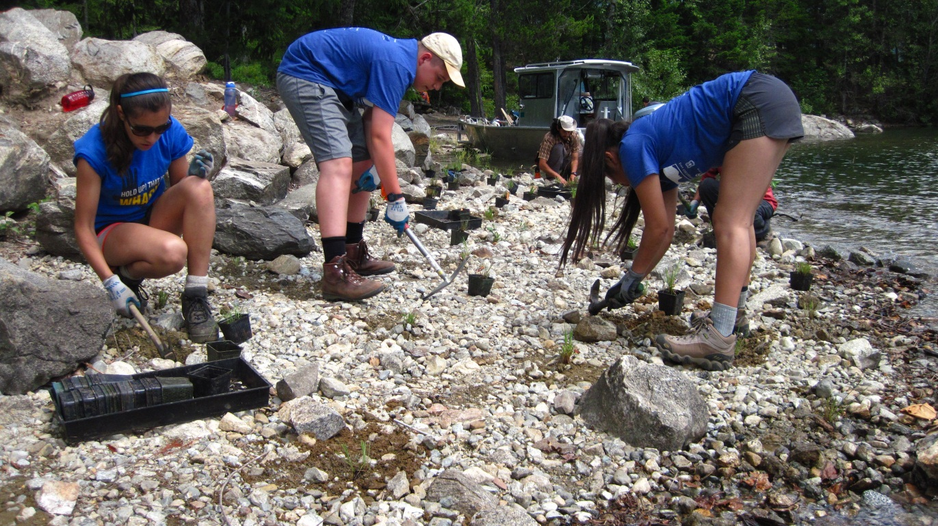

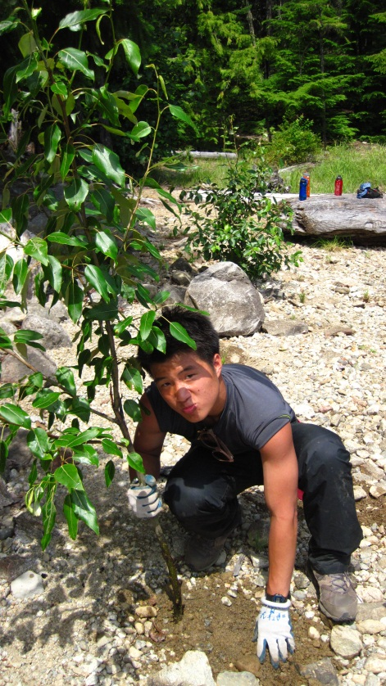
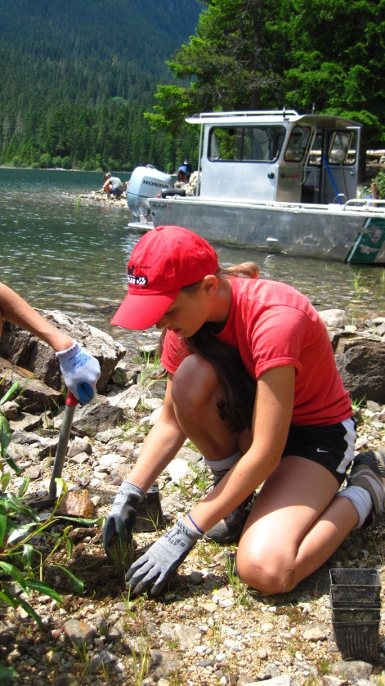

Photos 1-3. Planting at Big Beaver with North Cascades Institute student group in 2013.

