Sycamore Maple Control Along the Skagit River Through Newhalem

1 Background History
Landscaping of Newhalem was initiated in 1929 by J.D. Ross with the planting of several hundred ornamental trees to “beautify” the town. Planting trees and shrubs continued through the 1930’s and peaked in 1938. Nearly all the planted trees were non-native species typical of urban and suburban landscapes throughout North America and Europe. Sources included the Seattle Parks Department, U.S. Department of Agriculture, Franklin D. Roosevelts Hyde Park compound, Washington D.C., and other locations throughout the county. Over time the town has changed—roads were installed, structures were added or demolished—and many of the trees planted by Ross died or were removed and replaced with others. For a more detailed history of the Newhalem landscape, see Tolon (1994) Appendix A.

A variety of ornamental tree species currently dominate the Newhalem landscape. These include the iconic cherry trees that line Cherry Tree Lane and the sycamore maples, butternuts, European beech, red oaks, and black walnuts that are found in throughout the town. Some native species occur as well, including big-leaf maple, vine maple, Douglas-fir, and western red cedar. An assessment of the condition of 236 trees in Newhalem and Diablo was conducted in 1998 (Urban Forestry Services). Of the trees evaluated, most were rated as being in fair to good condition, with an expected longevity of 25->50 years.

2 The Problem
In 2013 the City Light Environmental Lead for the Skagit and the Skagit Gardener noted that much of the riparian vegetation on the west side of the bridge to Trail of the Cedars is dominated by sycamore maple—which at a glance is very similar in appearance to big-leaf maple, particularly younger trees. Additional investigation by City Light ecologists and a student group from Seattle University found that sycamore maple and a variety of other non-native tree species were pervasive in the riparian area along the Skagit River from Ladder Creek bridge through Newhalem to the last of the Cherry Tree Lane houses Patches of sycamore maple have been documented along both sides of State Route 20 through Newhalem and south to Goodell Creek and on the west bank of the Skagit River past the bridge to Newhalem Campground to Goodell Creek. Other commonly occurring non-native tree species in these areas include red oak, horse chestnut, English hawthorn, European beech, and black walnut.

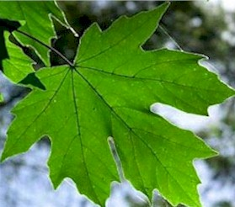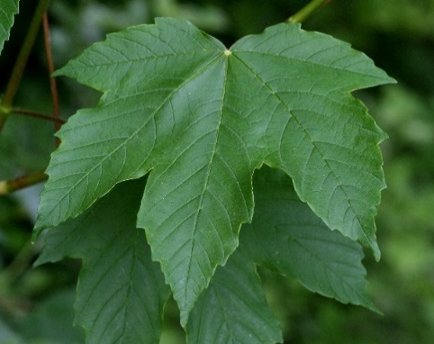
Big-leaf maple Leaf Sycamore maple Leaf

The Skagit River riparian zone, the highway corridor and the transmission line ROW through Newhalem were cleared of most native trees and shrubs during the development of the town. The lack of native plant cover and ground disturbance apparently created optimal conditions for colonization by sycamore maple, as well as other invasive species. Sycamore maple is particularly problematic because it grows fast in open areas, becomes reproductive while still relatively small, and produces very large quantities of winged seeds (samaras) that are easily carried by wind and germinate quickly. In fact, the pattern of sycamore maple colonization in Newhalem is clearly associated with the prevailing wind direction in the valley—which is from east to west, or down valley. There are relatively few sycamore maple trees at in the eastern portion of the town and most of these are mature trees that are part of the landscape. The many younger trees, which grew from seed, occur further west, downwind of the mature specimens. There is no evidence of sycamore maple occurring along the river upstream of Newhalem.

3 Project Description
The purpose of the sycamore maple control project is to prevent the continued spread of this species from Newhalem onto surrounding federal lands and further downstream along the Skagit River. This will likely require the eventual eradication of the species from Newhalem but the project will need to be accomplished in phases and with multiple methods. While the control project is focused on sycamore maple, a few selected specimens of other landscape trees that have also spread beyond the perimeters of Newhalem will also be targeted for removal.

The existing mature trees are part of the historic landscape and provide shade and visual interest to the town. Although they are the most prolific seed producers, removing and replacing them all at once would significantly change the appearance of the town for many years. Similarly, the existing trees along the west side of Skagit River through Newhalem comprise a large portion of the forest canopy in the riparian zone. Clearing them all at the same time would reduce the amount of available shade and allochthonous input to the river for years, even with dense replanting, and could increase the risk of erosion.

This project description is for phase 1 of the sycamore control project in Newhalem; the results of phase 1 will inform the scope and timing of subsequent phases. Phase 1 will be focused on the riparian area and adjacent landscape (east of the north-south residential road through Newhalem) from roughly Gorge Inn to the powerline crossing behind the firehouse (see Figure 1). Phase 1 has three main tasks:

Task 1 – Remove and Replace Select Mature Landscape Trees from Newhalem
Task 2 – Remove/EZ-Ject Reproductive Trees from Riparian Area through Newhalem
Task 3 – Replant Riparian Zone

Task 1: Remove Select Mature Landscape Trees from Newhalem
A total of 8 large landscape trees in Newhalem in the area between the north-south road through the east side of town have been identified and flagged (yellow) for removal (Table 1; bolded numbers). Two are adjacent to planting areas at the entrance to Trail of the Cedars, the others are across the road from
Table 1 Trees to be removed from Newhalem landscape and adjacent riparian zone
Tree/Site #¹ | Species | DBH  (in.) | General Location & Condition
1 | Black walnut | 26.5 | Near Trail of Cedars planting area; most of one side missing
2 | Black walnut | 17.0 | At top of bank near Trail of Cedars Bridge; small, most limbs missing
3 | Sycamore maple | 5-13 | Cluster of 10 reproductive trees on the right side of Trail of Cedars Bridge between bridge and large western red cedar
3 | Golden-chain tree | <6 | Cluster of small golden-chain trees/shrubs along bank to the right of and under Trail of Cedars Bridge.
4 | Sycamore maple | 4-10 | Cluster of 7 reproductive trees on the left side of Trail of Cedars Bridge between bridge and large western red cedar
5 | Sycamore maple | 21.5 | Across from Gorge Inn; thin canopy, dead limbs.
6 | Sycamore maple | 20 | Across from Gorge Inn; thin canopy, dead limbs.
7 | Sycamore maple | 28 | Across from Gorge Inn; thin canopy, dead limbs.
8 | Sycamore maple | 21 | Across from Gorge Inn; thin canopy, dead limbs.
9 | Horse chestnut | 22 | Across from Gorge Inn; thin canopy, dead limbs.
#110 | Kentucky yellowwood | 11 | In parking strip, across from Currier Hall; leaning, severely pruned in the past, may be hollow (metal tag on tree #110)
10 | Sycamore maple | 19 | Behind House 222 (Teacher’s House)
11 | Sycamore maple | 14 | Behind House 2
12 | Sycamore maple | 19.5 | Part way down the bank between Houses 18 and 19
13 | Sycamore maple | 22 | Part way down the back behind House 18
14 | Sycamore maple | 22 | Yard behind House 18.
15 | Sycamore maple | 12 | Near powerline crossing the Skagit River
¹ Bolded numbers are landscape trees.
Gorge Inn. Several of these appear to be in poor condition, as evidenced by broken tops, dead limbs, and thin canopies. This will result in the loss of about one-quarter or so of the trees in this area. However, the remaining large trees, the dense canopy along the adjacent river bank, and the installation of larger replacement trees should help mitigate the visual changes. See photos at end of document.

The large trees identified for replacement in Newhalem will be cut down by the City Light Skagit Vegetation Management Crew using chainsaws and hand equipment. The trees will be limbed and the main trunk saved as whole, to the extent possible. Cutting will occur in late winter or early spring 2017 before seeds have a chance to develop. Limbs and debris will be chipped if free of samaras. Debris with samaras will be composted under plastic to kill the seeds. Stumps will be ground.

City Light will offer the trunks for sale to the highest bidder who can also pick up and remove the wood from the site. Both sycamore maple and black walnut are valued for furniture making and the hope is that it can be put to good use by a craftsman in the Skagit Valley.

The landscape trees will be replaced one-to-one with primarily deciduous species to be consistent with the historic concept and the appearance of the area. To the extent possible, larger specimens (>8 ft) will be planted. The replacement species selected will either be native to northwest Washington or non-native with a low probability of spreading. City Light has developed a list of replacement trees for the Newhalem/ Diablo landscapes (Appendix A). Specific replacements for the landscape removals may include the following species, depending on availability:
- Big-leaf maple
- Tulip Tree
- Oregon Ash
- ‘Starlight’ Dogwood
- Common Stewartia

Task 2 – Remove/EZ-Ject Reproductive Trees from Riparian Area through Newhalem
Most of the reproductive sycamore maple in the riparian zone to be removed in Phase 1 will be injected with glyphosate using an EZ-ject system. This work will be accomplished by a crew from the Skagit Fisheries Enhancement Group (SFEG) in 2017. The trees are expected to die over 1-2 years.

Nine trees in the riparian zone through Newhalem, from just upstream of the bridge to Trail of the Cedars to the powerline across the Skagit River, were identified for cutting. Trees in sites 3 and 4 are clusters of small-to-mid-sized reproductive specimens adjacent to both sides of the west end of Trail of Cedars bridge. This is a very steep bank in a high visibility area. Most of the trees are sycamore maple but there are also several small golden chain trees, which is also a non-native invasive species. At these sites the trees will be cut by a City Light crew, mulched and seeded with a sterile seed mix to prevent erosion.

Trees 10-15 are mid-sized reproductive sycamore maples growing in the backyards of several Newhalem houses or along the banks behind houses. These six trees were identified for cutting by City Light crews because they are relatively close to houses and could cause damage if they were to fall after being killed by the herbicide that will be used kill other trees in the riparian zone.

The stumps of cut trees will be treated with glyphosate to prevent resprouting. Limbs and debris will be chipped if free of samaras. Debris with samaras will be composted under plastic to kill the seeds. Trunks from the three yard trees maybe cut into chunks and provided to residents or sent to the Ag Pond storage area where it would be available for fire wood. Trunks from three trees in the riparian zone will be left as large wood.

Task 3 – Replant Riparian Zone
Replanting in the riparian zone will be done by SFEG in 2017. The two areas adjacent to the Trail of the Cedars bridge will be planted with a mix of x gallon specimens of western red cedar, big-leaf maple and cottonwood and a variety of understory species such as sword fern and Oregon grape. There is a nearby water source, so these plantings may be watered during the summer to increase survival.

The riparian area downstream of the bridge to the powerline crossing will be planted with a mixture of western red cedar and cottonwood near the river and big-leaf maple and Douglas-fir on the upper bank. Planting will occur in conjunction with other weed-control measures in this area in 2017 and 2018.

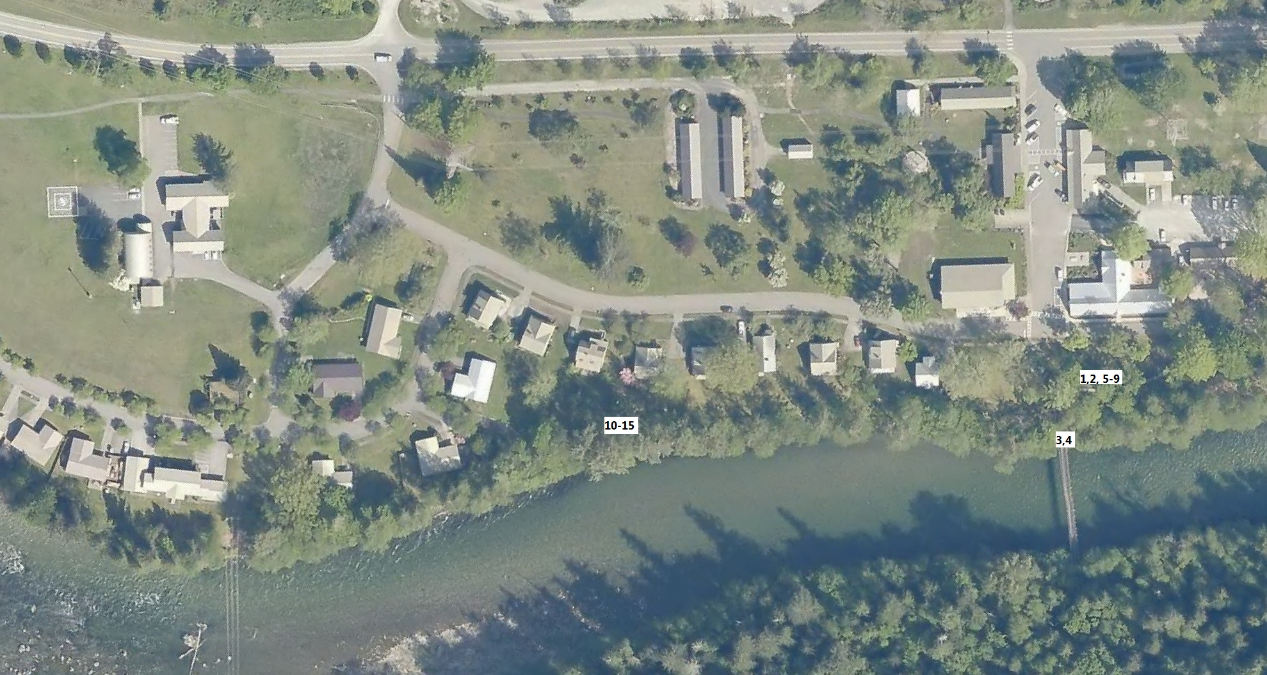
Figure 1. Project area (red).
Blue dashed area – Location of Trees 1, 2, 5-9.
Orange area - Tree sites 3 and 4

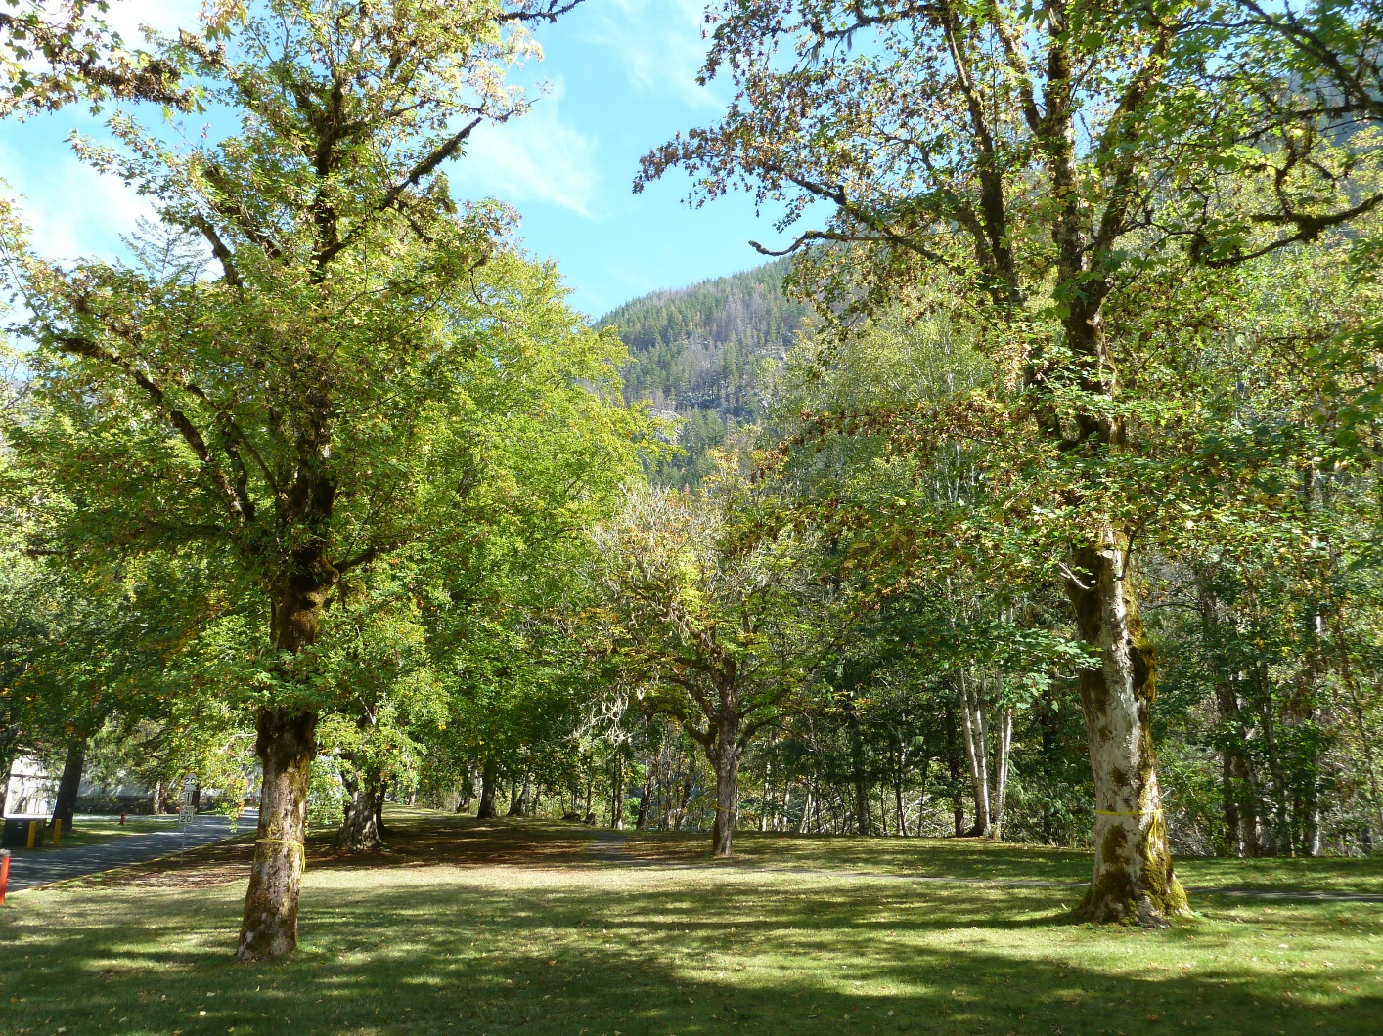
Figure 2. Three of the five trees that will be removed from landscape across from Gorge Inn

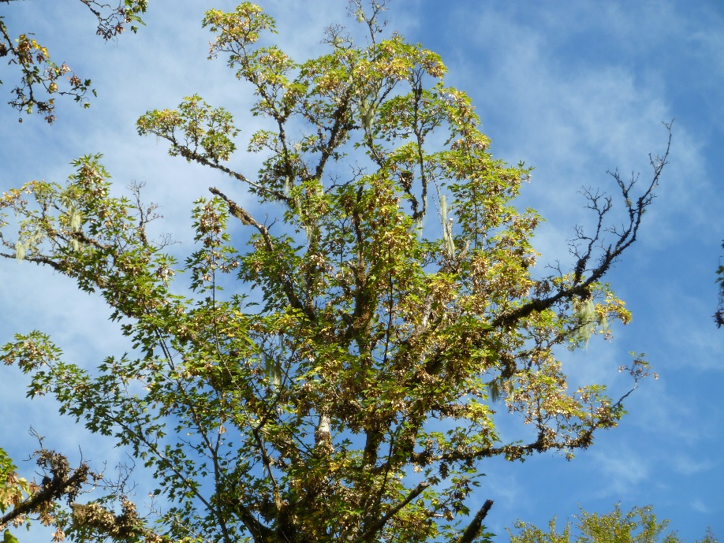
Figure 3. Canopy of one of the trees above.
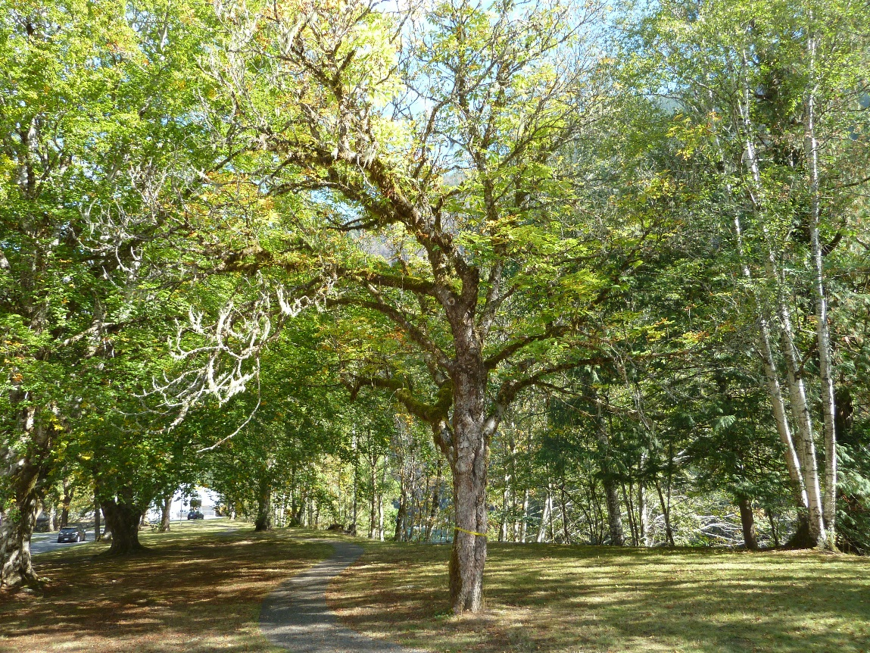
Figure 4. Sycamore maple in landscape area across from Gorge Inn flagged for removal
Note thin canopy on right side

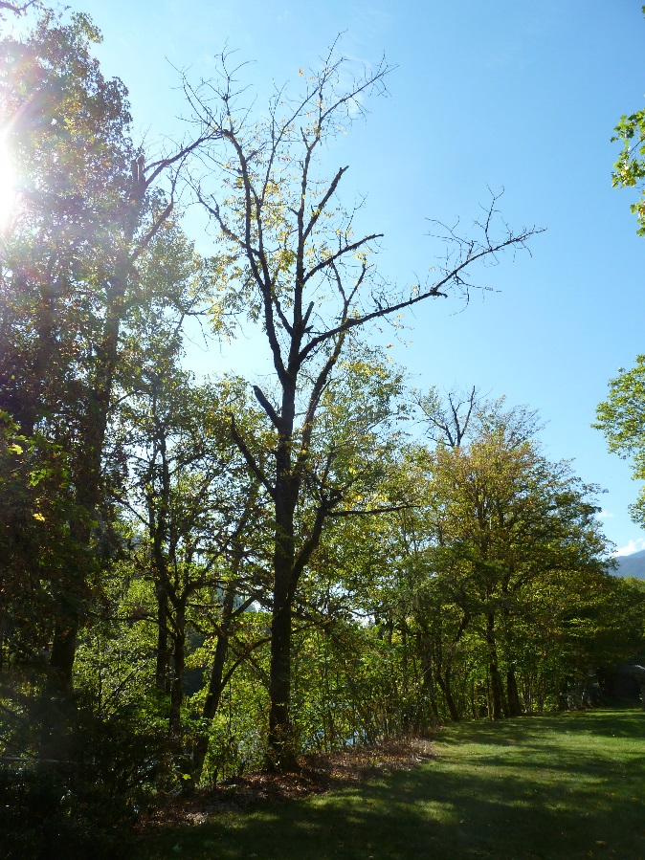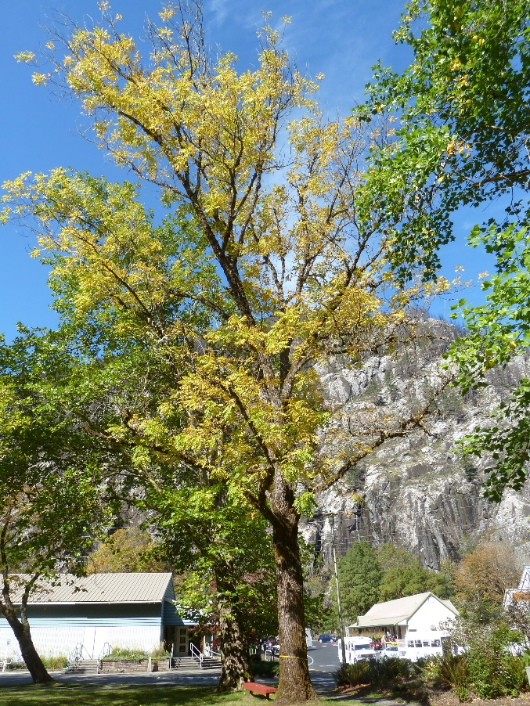
Figure 5. Black walnuts marked for removal. Note dead branches, pre-mature yellowing
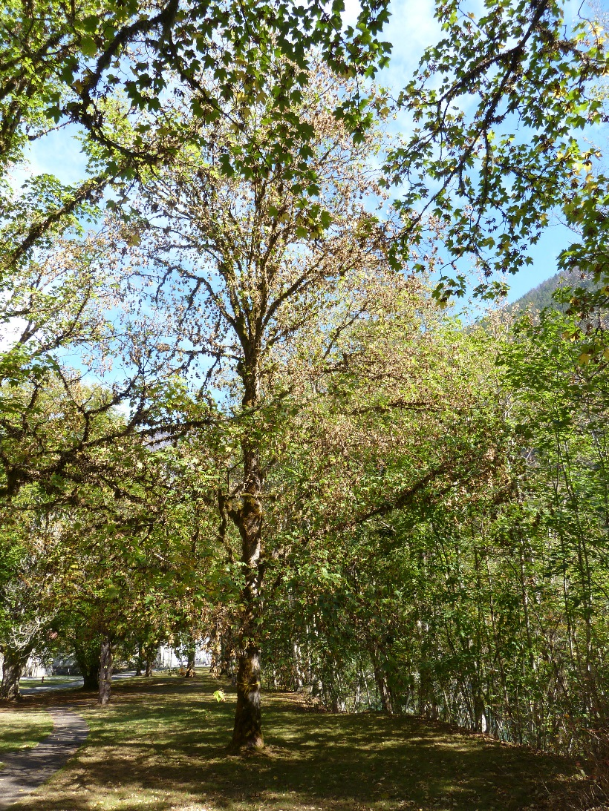
Figure 6. Sycamore maple in landscape area across from Gorge Inn flagged for removal. Note thin canopy.

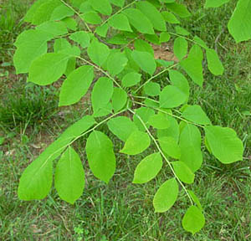
Example Kentucky Yellowwood leaf Example of Horse Chestnut leaf and fruit
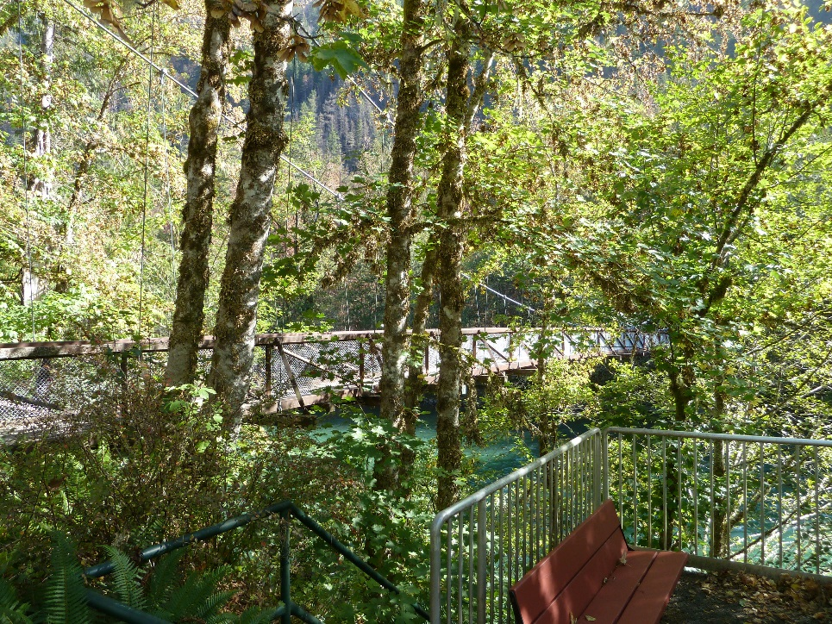
Figure 7. Cluster of sycamore maples on south side of bridge to Trail of Cedars
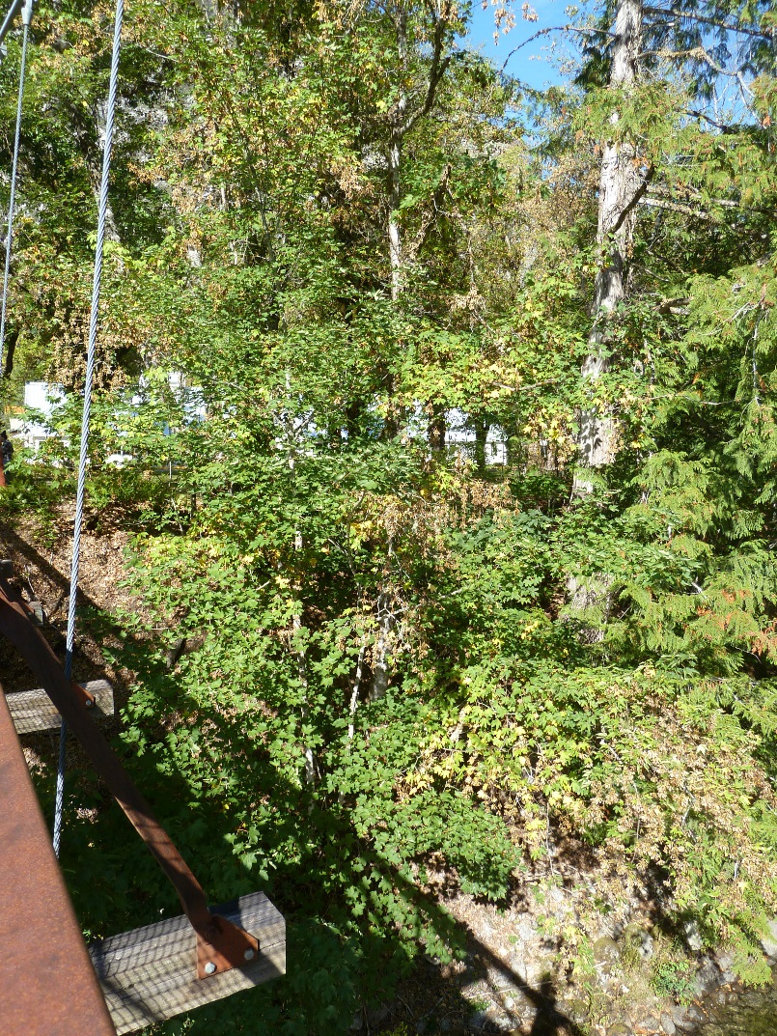
Figure 8. Sycamore maple cluster on north side of Trail of Cedars Bridge

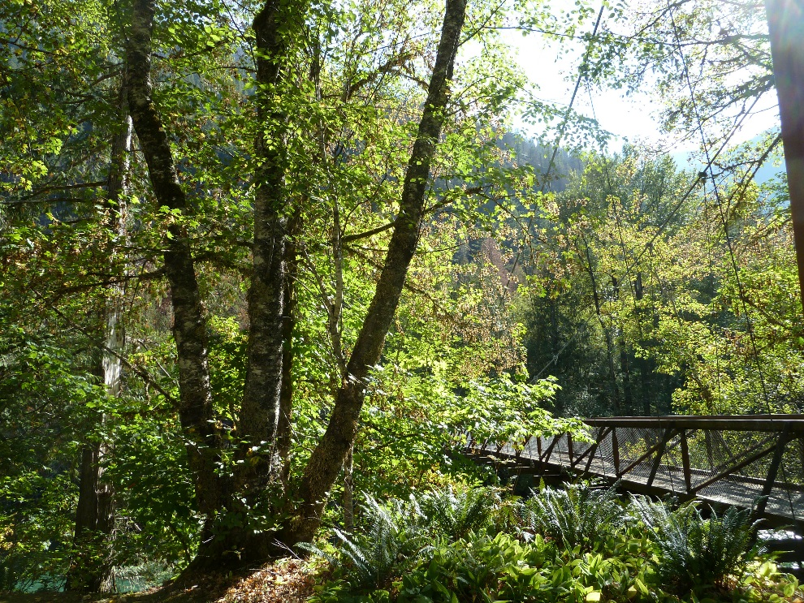
Figure 9. Same area from top of the bank. Pacific birch tree in foreground will remain

Appendix A
Potential replacement trees for Newhalem/Diablo landscapes

Goal: Select new plant material compatible in character, habit, form, and massing to vegetative patterns and landscape design indicative of the significant historic period, 1920-1941. The list below includes species native to the Pacific Northwest, non-invasive trees historically included in the Newhalem/Diablo landscapes and non-invasive, tree species with similar character and habit.

Full Sun, dry
Large: Species Source
Garry Oak Quercus garryana Nat, 1998R, GPP
Big Leaf Maple Acer macrophyllum Nat, Pre-war
Douglas Fir Psuedotsuga menziesii Nat,
Western Larch Larix occidentalis Nat
Bitter Cherry Prunus emarginata var. mollis Nat
Lodgepole pine Pinus contorta var latifolia Nat
Ginko Ginko biloba 1998R, GPP
Giant Sequoia Sequoiadendron giganteum 1998R

Medium:
Starlight® Dogwood Cornus ‘Starlight’ GPP
Shore pine Pinus contorta var contorta Nat

Small:
Douglas Maple Acer glabrum var douglasii Nat
Eddie’s White Wonder Dogwood Cornus ‘Eddie's White Wonder’ GPP
Venus® Dogwood Cornus ‘Venus’ GPP
Autumn Brilliance serviceberry Amelanchier × grandiflora ‘Autumn Brilliance’ GPP
Golden Chinquapin Chrysolepis chrysophylla Nat
Flowering Crab Apple Malus ‘Sutyzam’ SUGAR TYME Pre-war, GPP
Persian Ironwood Parrotia persica 1998R, GPP
beaked hazelnut Corylus cornuta Nat

Full sun, moist
Large:
Aspen Populus tremuloides Nat
Oregon Ash Fraxinus latifolia Nat
Paper Birch Betula papyrifera Nat
Tulip Tree Liriodendron tulipifera 1998R

Medium:
Pacific Crabapple Malus fusca Nat
Shirofugen Cherry Prunus serrulata ‘Shirofugen’ 1998E

Small:
Akebono Cherry Prunus × yedoensis ‘Akebono’ GPP
Snow Goose Flowering Cherry Prunus ‘Snow Goose’ OSU
Black Hawthorn Crataegus douglasii Nat
Oyama magnolia Magnolia sieboldii Pre-war, GPP

Full sun, wet
Large:
Pacific Willow Salix lasiandra Nat, Pre-war
Dawn Redwood Metasequoia glyptostroboides 1998R

Medium:
Cascara Rhamnus purshiana Nat
Black Gum Nyssa sylvatica 1998R, GPP

Shade, dry
Large:
Grand Fir Abies grandis Nat, GPP

Medium:
Western Dogwood Cornus nutallii Nat

Small:
Eddie’s White Wonder Dogwood Cornus ‘Eddie's White Wonder’ GPP
Vine Maple Acer circinatum Nat, Pre-war

Shade, moist
Large:
Western red cedar Thuja plicata Nat, Pre-war, GPP
Pacific Silver Fir Abies amabilis Nat
Coast Redwood Sequoia sempervirens GPP

Medium:
Kobus Magnolia Magnolia Kobus 1998E, GPP
Saucer Magnolia Magnolia x Soulangeana Pre-war, 1998E

Small:
Vine Maple Acer circinatum Nat, Pre-war
red-bark vine maple Acer circinatum ‘Pacific Fire’ GPP
Western Yew Taxus brevifolia Nat
Common Stewartia Stewartia pseudocamellia 1998E

Nat= Native
GPP= Great Plant Picks
1998R= Recommended in 1998 Arborist Report based on landscape aesthetics
1998E= Existing in 1998 Arborist Report
Pre-war= PRE-WAR (1920-1941) PLANT LIST

