RECOMMENDATION OF THE
DOWNTOWN DESIGN REVIEW BOARD

Project Number: 3018131

Address: 2229 6th Av

Applicant: Michael Medina, Graphite Design Group, for Clise Properties

Date of Meeting: Tuesday, July 07, 2015

Board Members Present: Murphy McCullough, Chair
Anjali Grant
Grace Leong

Board Members Absent: Alan McWain
Gundula Proksch

DPD Staff Present: Michael Dorcy

SITE & VICINITY
Site Zone: DMC 340/240-400

Nearby Zones: (North) DMC 240/290-400
(South) DMC 340/240-400
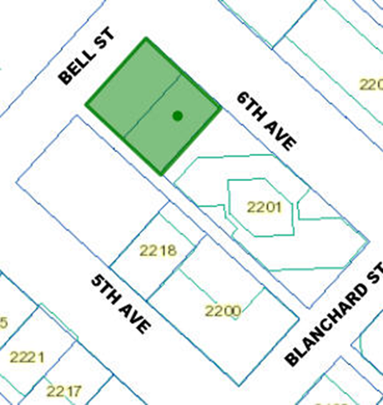
(East) DMC 340/240-400
(West) DMC 240/290-400

Lot Area: 12,960 sq. ft.

Current Development:

Surface parking lot

Surrounding Development and Neighborhood Character:

The area is in transition, a mix of older commercial buildings of limited height and newer high rise construction, both office and residential buildings. The area was up-zoned in 2005 to allow for increased height and density. Bell Street on the north is a designated “Green Street,”

Access:

Access from alley to the west

Environmentally Critical Areas:

None on site or in immediate area

PROJECT DESCRIPTION

At the EDG meeting, conducted on October 21, 2014, the applicants had proposed an eleven story, 165,000 sq. ft. data processing facility with approximately 10,000 sq. ft. of retail at grade. Parking for 32 vehicles below grade, accessed from alley.

In response to technical as well as market conditions, the data tower proposed at the EDG meeting has been reduced in height from 268’ to 171’, a reduction of 36 percent in height. Changes in the basic proportions of the building have elicited some changes to the basic design. Another floor, office space, has been added to the double height portion at the base of the building, making the box at the base some forty feet in overall height. The programmatic revision can be easily seen in the graphic on page A-8 of the packet.

Recommendation Meeting, July 7, 2015
The packet for the meeting includes materials presented at the meeting, and is available online by entering the project number 3018131at this website: http://www.seattle.gov/dpd/Planning/Design_Review_Program/Project_Reviews/Reports/default.asp.

The packet is also available to view in the file, by contacting the Public Resource Center at DPD:
Mailing Address: | Public Resource Center  700 Fifth Ave., Suite 2000  P.O. Box 34019  Seattle, WA 98124-4019
Email: | PRC@seattle.gov
The packet for the Early Design Guidance meeting held on October 21, 2014 is also available at the website noted above:
http://www.seattle.gov/dpd/Planning/Design_Review_Program/Project_Reviews/Reports/default.asp.

DESIGN DEVELOPMENT

As noted above, in response to technical as well as market conditions, the data tower proposed at the EDG meeting has been reduced in height from 268’ to 171’, a reduction of 36 percent in height. Changes in the basic proportions of the building have elicited some changes to the basic design. Another floor, office space, has been added to the double height portion at the base of the building, making the box at the base some forty feet in overall height.

The project use is defined as an “utility building,” whose function, as described by the applicant, is that of a “data center.” The building will house computer systems and associated components, “such as web cloud and data storage.” The building will contain redundant data communication connections, environmental controls, as well as various security devices.

The data center’s cooling system is designed to support the export of heat to surrounding buildings, potentially fulfilling the majority of their hydroponic heating energy requirements.

The data center will also house limited office space and control rooms, but primarily it will be filled with data equipment. Human occupancy will be an IT staff of approximately thirty individuals.

PUBLIC COMMENT SUMMARY

No written comments were received during the official comment period that ended on February 8, 2015. The Department received, prior to the EDG meeting on October 21, 2014, a single comment, critical of the inadequacy of proposed parking for the project (38 spaces proposed at that time).

PRIORITIES & BOARD DELIBERATIONS

After visiting the site, considering the analysis of the site and context provided by the proponents, and soliciting public comment, the Design Review Board members provided the following comments and directives.

Regarding the tower massing and architectural expression, the Board had strongly recommended that the base be seen as a single articulation and expression, with a clear physical separation of the tower and base. In addition, the Board supported the layering of the tower facades, which would by necessity be windowless, and contrasting them from a strongly transparent and crystalline (“jewel-like”) base. This double-height base had been enhanced with a heightened office level, read as a single expression with the ground-floor retail space.

The Board had also recommended a linking of the tower to base by means of a vertical seam while separating the base and tower with a pronounced horizontal belt. The binary patterning of the tower was replicated in the mullion patterning of the glass base.

At the EDG meeting the Board had pointed out that the enlarged canopy above the secure ground floor building entry overly emphasized the entry. The Board was still troubled by the size and prominence given to the entry canopy. While the canopy was important to identify the entry, they advised that the canopy be integrated with the overhead weather protection proposed along the entirety of the 6th Avenue street-level façade.

Among other refinements recommended by the Board were the following:

- Design the entry doors at the ground level so that they are incorporated into the overall binary pattern of the tower and the fenestration of the base.
- Continue to study and evaluate the precise thickness of the edging of the tower and the nosing of the base to get them just right.
- Plan for the possibility of smaller retail components; this would involve both the potential location of additional entries and the integration of such additional entries into the proposed “greenstreet” treatment of Bell Street and the landscaping for plants and street furniture along 6th Avenue.

The Board expressed their approval of the design and the choice in materials they had been shown. They likewise approved the proposed adjacent street–level improvements along the two street fronts. They commended the applicants on the design development and on the choices they had made in concert with the Board’s guidance and with the design guidelines the Board had identified as of highest priority for the success of the project. Together with the refinements noted above, the Board was confident in the applicants’ ability to produce a successful project on this site and recommended approval of the proposal by a vote of 3-0.

DEVELOPMENT STANDARD DEPARTURES

The applicants did not request any departures from development standards.

