Appendix A:
Contract and Reporting Requirements:

Contract Exhibit B-3: Agency Invoice ………………………………………. Page 2
Action Plan Progress Report…………………………..…….…..………….. Page 3
Annual Outcomes Reporting……….…………………………..…….…..…. Page 4

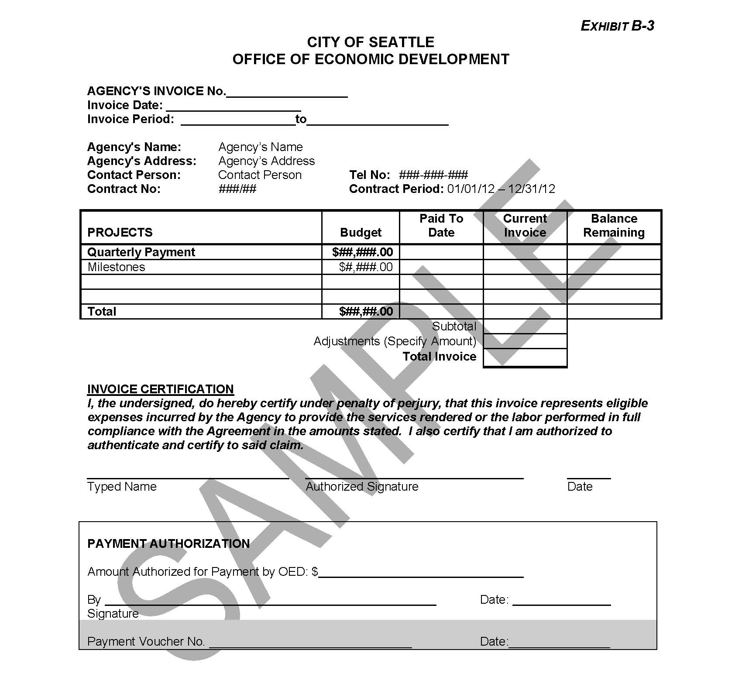
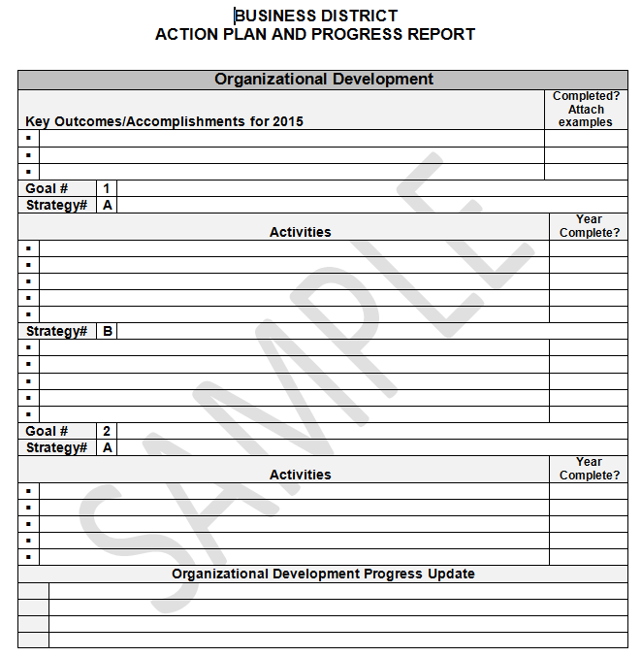

Only in Seattle Outcome Reporting Form

Business District Results | 2016 | Details (name of events, projects, etc.; note major accomplishments)
Total businesses in the district |  | [As of year-end]
Estimated net new jobs created |  | [As of year-end]
Businesses connected to technical assistance
Total # of promotional activities
Total # of cultural events
Total # safety activities
Total # cleaning activities
Promotional, cultural, safety and cleaning events held in the district |  | [Sum of four rows above]
Total # of businesses and property owners participating in business district activities
Total # of volunteers participating in business district activities |  | [Excluding any from row above]
Volunteer businesses and residents working on district projects |  | [Sum of two rows above]
Total amount of public funding leveraged
(List Projects Included in total)
Total amount of private funding leveraged
(List Projects Included in Total)

