Instructions to Apply for a Concealed Weapons Permit by Mail

The Seattle Police Department offers a convenient option to apply for a Concealed Weapons Permit by mail.

Fingerprints must be taken by a 3rd Party for all new applicants applying by mail. You will need to contact one of the vendors below and arrange to get fingerprinted, prior to submitting your application.

Once you have been Fingerprinted, you will need to submit your fingerprint card sealed by the selected fingerprinting service to the SPD Public Request Unit by mail, together with your completed application packet and fee.

Link to Application.
https://www.dol.wa.gov/business/firearms/training/652007.pdf

Below a list of vendors offering Fingerprinting services you may contact.

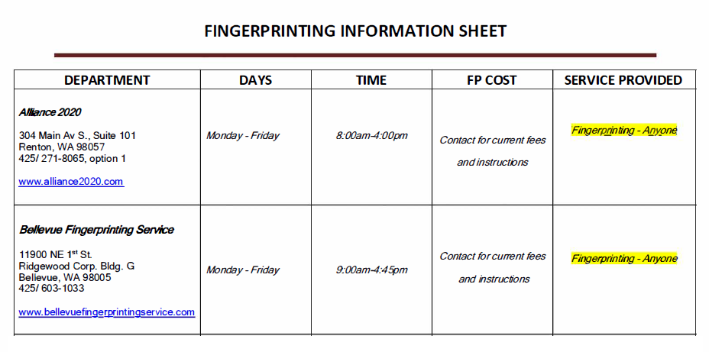

**Fingerprint vendors may charge fees for their services.

ALL APPLICATIONS MUST BE RECEIVED WITH THE FOLLOWING:

• Completed and Signed CPL Application
• Copy of Current Valid Washington identification with a Seattle Address listed (Driver’s License, Permanent Resident Card) School ID cards or expired cards are not valid.
• Money Order or personal check in the amount of $49.25 payable to City of Seattle
• Fingerprint cards in envelope sealed by business/agency who took them

Mail completed application and documentation packet to:

Seattle Police Department
Attn: Public Request Unit/CPL Desk PO Box 34986
Seattle, WA 98124-4986

***Please also provide a method of contacting you in the event there are questions or issues with your submission.

Concealed Pistol License Requirements

Applicants must be at least 21 years of age, citizens of the United States (or permanent resident aliens), and live within Seattle city limits. They must possess a valid picture identification or otherwise
provide proof they have lived in the state for at least the last 90 days.

