Seattle School Traffic Safety Committee
FINAL November 20, 2015 Minutes

Attendees
Members: Ashley Rhead (Seattle Department of Transportation), Shannon Koller (Cascade Bicycle Club), Richard Staudt (Seattle Public Schools), Cathy Tuttle (Seattle Neighborhood Greenways), Brian Dougherty (Seattle Department of Transportation), Yvonne Carpenter (Seattle Public Schools), Kyle Brown (Seattle Public Schools), Jen Cole (citizen rep)

Other Attendees and Presenters: Michelle White (Seattle Public Schools Transportation)

Public Attendees: None

Public Comment: None

October Minutes: Approved

Approval of September Minutes and Review of Action Items
- Stop Paddle updates:
  - Kyle Brown reports that SPS is opening up conversations with King County about a potential partnership for yellow school bus stop paddle violations.
  - The proposal is for the King County Sherriff’s office to execute the vetting and processing of tickets. The Seattle Police Department continued to ask for costs that are too high for a workable partnership.
- Speed Humps Near Schools – Policy:
  - Brian shared a copy of the Vancouver, BC policy on speed humps near schools. The policy is not much different in writing than what SDOT already uses.
  - Brian proposes that instead of modeling a policy on Vancouver’s, we instead match our school zone policy to the Neighborhood Greenway policy. That would allow for speed humps at every school, and would also help meet the Mayor’s goal of having SRTS at every school in the City.
- Sacajawea Crossing Guard:
  - The issue from last month is that the crossing guard on 15th Ave NE, near Sacajawea, is crossing people at a different stop than assigned because that is the natural crossing place for families.
  - Ashley submitted a request to do counts at the current location and at the assigned location.

ACTION: Ashley to share results of counts.

- Follow-up on John Rogers Bus Location Assignment:
  - SPS and John Rogers Elementary administration continue to look into changing bus zone to the far side of the playfields.

ACTION: Kyle to meet with administration after the holidays.
ACTION: Jen to send Kyle and Michelle information about do-it-yourself circulation plans (from Feet First).

Bike-Ped Curriculum Update
- Shannon reports that the process for creating the 3rd/4th/5th grade curriculum is going well. The curriculum team met last Monday and will work to align curriculum to new state P.E./Health standards.

Mode Choice Executive Summary Infographics
- Ashley distributed a one-page infographic summarizing the extensive analysis of the Mode Choice Surveys (below). Committee members reviewed the materials and set out plan to distribute to stakeholders.
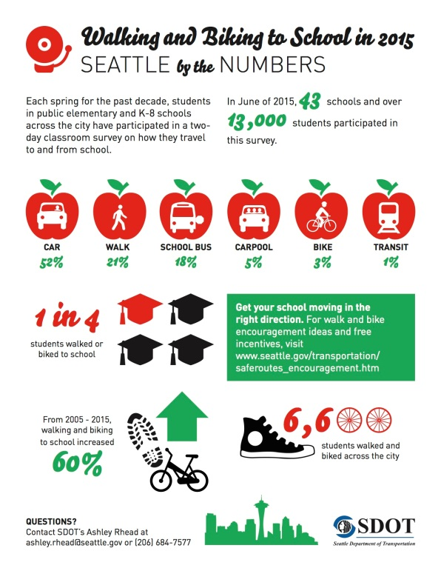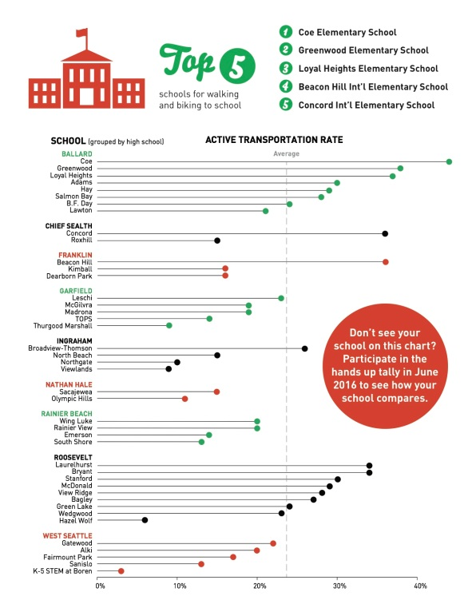

ACTION: Ashley to email PDF to Committee members.

ACTION: Michelle will bring hard copies to her schools. Kyle will have all intervention specialists do the same.

ACTION: Cathy to send Seattle Times contact to Ashley.
ACTION: Ashley working with Lisa Quinn of Feet First to get information included in Seattle’s Child magazine and distributed to the SRTS Action Network.

ACTION: Kyle to share with SPS Communications.

ACTION: Shannon will send to all Bike to School Leaders

What Levy Passing Means for SDOT’s SRTS Program
- Since the Transportation Levy passed earlier this month, SDOT can now look for leveraging opportunities, especially for Neighborhood Greenways.
- To make the sidewalk money stretch as far as possible, SDOT is researching options for at-grade walkways and other price-smart innovations. Money for sidewalks around schools will be prioritized.
- SDOT also plans to improve existing at-grade sidewalk, adding buffers where needed. Seattle actually has a fair number of at-grade sidewalks, especially in SE Seattle, which could be improved with a variety of engineering options.
- Cathy points out that there is language in the new levy agreement requiring every large road project to be looked at with a SRTS and Equity lens.

Red Light Camera Funds
- Nick Licata’s proposal to get 10% of red light camera funds into SRTS projects has passed. Otherwise, these funds were getting sent to the City’s general fund.

Follow-Up to Rainier Beach High School Buss Pass Campaign
- Ashley reported that the City Council also passed a $1 Million dollar fund for Orca passes for SPS students. Metro and SPS will soon start work on an implementation plan.
- The understanding at this point is that the plan will prioritize low-income high school students throughout the city, with any left-over money going to help middle school students obtain Orca passes.
- Councilmember O’Brien was key to getting this to happen.

Speed Camera Violation Statistics
- Richard O’Neill was not able to attend today’s meeting, but sent the speed camera violation statistics for our review.

Crossing Guard Assignments
- Ashley asked the Committee to revisit citywide crossing guard assignments according to the prioritization formula, with heat maps factored in. Now that we have a data-based system to prioritize, we will need to look at locations that are currently staffed but have lower priority status than open ones.
- This committee needs to establish a communications plan for speaking with school communities about crossing guard policy, especially for those schools that will lose guards in historically staffed, low priority locations. It was decided to create a working subcommittee to attend to this task. Of those committee members present, Brian and Jen volunteered for this sub-committee.
- The timing will be to be ready to implement changes by next school year (9/16).

ACTION: Ashley to send out invitation to all committee members to fill out the subcommittee.

Crossing Guard Updates
- Yvonne reports that there is a new guard at Dearborn Park.
- There is an afternoon guard at 80th and Greenwood. Greenwood Elementary administration has asked to move that person to 3rd Ave and 81st. Observations have shown not many people crossing there, although they have placed flag buckets there. The speed on 3rd is too high for student patrol.

ACTION: Ashley to add 3rd and 81st to the spreadsheet and see how it ranks. If it ranks low, Yvonne will say no to the principal. If it ranks high, the committee will revisit the issue next meeting.

Future Topics and Announcements
- Next month’s meeting will be rescheduled to December 18th for the holidays.
- Brian will send names and phone numbers of parking enforcement supervisors to Michelle.
- Load zones – implications of bell time changes for signage.

10:30am Adjourn

