

**Eliminating Racial Inequity in School Discipline**

**A Call to Action**

Despite Seattle’s overall high standard of living and reputation as a progressive city, racial inequities exist in every indicator of personal and community well-being. Our history of racism and the current impact of institutional and structural racism combine to restrict opportunities for people of color and immigrant and refugee residents, including in housing, health, criminal justice, jobs and within the educational system. In Seattle Public Schools only around half of Native American and around 60% of Black and Latino students graduate from high school- compared to around 85% of white students (Seattle Public Schools, 2012). One reason for this disparate outcome is racial inequities in discipline policies and practices. This call to action shares strategies for eliminating racial inequities in discipline. Our goal is to eliminate racial inequity in graduation rates and increase graduation rates for all Seattle Public School students.

There is currently significant interest in addressing racial inequity in school discipline, as evidenced by:

* The Race and Social Justice Community Roundtable’s Committee on Racial Disproportionality in Discipline has been working on the issue for over two years. The Committee has developed and implemented a training that has been delivered at numerous events, including in school communities and at conferences. Through a partnership with Cleveland High School, a pilot project has focused on incorporating racial equity into disciplinary policies and procedures, with a focus on restorative justice.
* The U.S. Department of Education has launched an investigation into discipline rates in Seattle Public Schools. They are looking into whether black students in Seattle are disciplined "more frequently and more harshly" than white students for the same infractions.
* The School District has convened two advisory committees, the Equity and Race Advisory Committee (sub-committees include Hiring and Retaining Teachers of Color, Professional Development, and Policy) and a Positive Climate and Discipline Advisory Committee.
* The School Board passed an “Ensuring Educational and Racial Equity” policy in August of 2012. This policy calls out the topic of disproportionality in discipline, and also calls for an action plan to be developed, implemented and reported on annually.
* Various community based efforts, including the Garfield PTSA, League of Education Voters, and the South East Seattle Education Coalition have advocated for eliminating racial inequity in discipline.

Racial inequity in discipline is a significant problem and demands urgent attention. According to Seattle Public Schools, in the 2010/2011 school year the percent of the entire student body that were suspended or expelled at least one time was 5.7 percent, which breaks down to approximately 1 in 20 students being suspended or expelled at least once during the school year (see figure 1). At 3 percent, white students were ½ as likely to be suspended or expelled at least once compared to the average. The percent of Hispanic/Latinos suspended/expelled closely tracked average at 6%, which was two times greater than whites, while Native Americans and Black/Africans were suspended/expelled at more than 4 times greater rate than whites and twice the average at 13% and 14%, respectively.

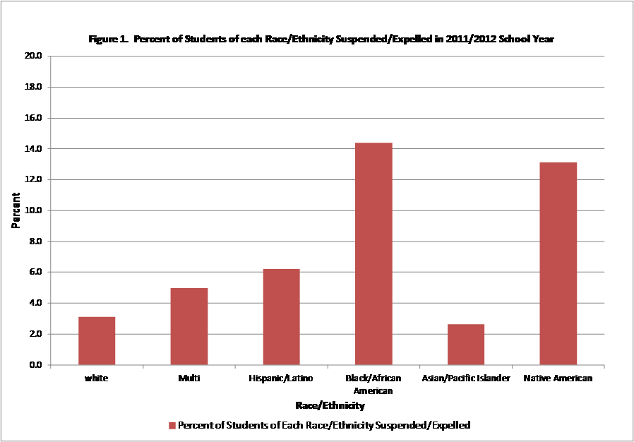

On June 1st, 2013 at the New Holly Community Center, the Race and Social Justice Community Roundtable sponsored an event that brought over one hundred people together to forge a unified strategy for racial equity in discipline.

This resulting "Call to Action” will guide District and community efforts to eliminate racial inequity in discipline.

For information on the Race and Social Justice Community Roundtable and the Racial Disproportionality in Discipline Committee contact Scott Winn at scott.winn@seattle.gov

**Eliminating Racial Inequity in School Discipline**

**A Call to Action**

1. Dramatically curtail out of school suspensions by changing policies and practices away from punitive punishments that perpetuate racial inequity.

Students not in school can’t learn and are more likely to get further behind and never return. Studies currently show that the general reliance on punitive approaches to discipline has proven largely ineffective in balancing school safety needs and addressing behavioral needs of individual students. Even after race and poverty are controlled for, studies have shown that higher rates of out-of-school suspension correlate with lower achievement scores (Skiba & Rausch, 2006). Over the long term, out-of-school suspensions are clearly associated with higher likelihood of school dropout and future incarceration. Specifically, students who have been suspended are three times more likely to drop out by the 10th grade, also tripling the likelihood of incarceration (Lieberman, 2007). The implementation of a district wide restorative justice program and restructuring of the discipline process towards alternative, behavior appropriate consequences will result in school discipline policies that focus on prevention and intervention, rather than on punitive approaches.

1. Create preventative policies in the discipline structure and institute a restorative justice program among staff and students
2. Shift funding from police presence in schools to restorative justice specialists
3. Modify discipline penalties to aptly reflect the severity of the student’s behavior and their individual needs
4. Develop consistent District-wide re-entry processes for students returning from suspensions and expulsions
5. Collect and disaggregate discipline and graduation data by race, and gather qualitative, anecdotal data that illuminates the context of student’s lives, including institutional barriers that influence individual student behavior

1. Strengthen teacher classroom leadership and create positive classrooms and school cultures and climates

By strengthening teacher classroom leadership skills, teachers will have the ability to create positive classroom climates and students will have equitable opportunity to succeed. Positive classroom climates address student needs by making positive changes in student’s environment which influences behavior. A growing body of developmental research highlights that challenges in adolescence (such as the need for close peer relationships, autonomy, and support from adults other than one’s parents, identity negotiation and academic self-efficacy) are directly and positively impacted by school support system that focus on positive reinforcement, behavior modeling, supportive teacher-student relations and family support. Schools implementing positive climate strategies have reported large reductions in discipline referrals, some as high as 50% (Skiba & Sprague, 2008). Establishing a common understanding of “positive school climate” and providing training and support to teachers will assist Seattle Public Schools in creating classroom environments that value students and encourage positive actions.

* 1. Develop, adopt, and implement a definition of “positive school climate”
  2. Provide culturally relevant curriculum that is accurate, respectful, and celebrates student diversity
  3. Provide continuous professional development opportunities focusing on racial equity practices in the classroom

1. Hire, support and retain qualified teachers of color

Data shows that students of color do better on a variety of academic outcomes when they are taught by teachers of color. According to Seattle Public Schools, the current teaching staff doesn’t reflect the diversity of students – 79% of teachers are white, while 44% of students are white; 7% of teachers are African-American and 21% of students are African-American; 8% of teachers are Asian-American and 22% of students are Asian-American; 3% of teachers are Latino and 12% of students are Latino; and .6% of teachers are Native American and 1.5% of students are Native American. While studies show that alternative routes and other non-traditional recruitment processes produce a greater percentage of teachers of color, it is also found that retention of these teachers of color in current school environments has proven difficult. Approaches that break down barriers to certification and expand recruitment processes, as well as improve the teaching experience of teachers of color, will help ensure a diverse and qualified teaching workforce. Restructuring the hiring process and building racial equity into job descriptions and interviewing processes will assist hiring teams. The addition of support mechanisms, such as mentoring for teachers of color, will positively influence retention.

* 1. Focus on hiring practices that increase staff diversity, including building racial equity into job descriptions, resume screenings and interview processes. Utilize research to determine hiring and retention best practices
  2. Review and improve district hiring processes, including improving the ability to make quick job offers to candidates
  3. Create support mechanisms in order to retain teachers of color, including mentoring and professional development
  4. Support development of alternative pathways to teacher certification
  5. Provide anti-racist organizational development training to assist teachers in navigating and transforming the policies and practices of the District
  6. Collect and report data on effectiveness of hiring and retention procedures

1. Develop and implement professional development and build the capacity within the district to eliminate racial inequity

Implementing professional development that is explicit about eliminating institutionalized racism and implicit biases, both system-wide and in classrooms, will build racial equity expertise in each school. The research is clear that effective instruction matters. At the school level, teachers are the single most important influence on student achievement (Skiba & Rausch, 2006). Teaching effectively in culturally appropriate classrooms means that teachers and school staff are aware of and utilizing culturally appropriate strategies and content that results in equitable academic opportunities and success. Additionally, staff must have the capacity to understand, adapt to and serve all students through eliminating classroom and system-wide barriers to academic achievement.

* 1. Embed racial equity analysis into all trainings to reinforce and integrate the content
  2. Create a racial equity training series for all staff and board members
  3. Develop and implement a train-the-training racial equity program to build skills and leadership within the District
  4. Evaluate student achievement and classroom culture after professional development to strengthen teacher leadership
  5. Establish Racial Equity Teams at every school to lead and focus efforts to eliminate racial inequities
  6. Utilize findings from the Department of Education investigation to further refine professional development

1. Promote a state-wide legislative agenda that fully funds education and supports improvements, including data collection about discipline, on a consistent basis.

It is imperative that we create a collective push that prioritizes fully funding education, supporting and improving opportunities for teachers and students and advocating for legislation that clearly reflects the impacts of race and equity. Washington State’s current budget still underfunds basic education by nearly two billion dollars (League of Education Voters, 2012). Legislation that supports ample, equitable and stable resources in school will help students succeed and provide support for teachers and staff.

* 1. Implementation of Washington State Supreme Court’s McCleary decision which required full funding of education to the standard set by the state constitution
  2. Pass legislation requiring teacher training on issues of racial equity and culturally relevant instruction, including for English Language Learners
  3. Pass legislation that supports the development of positive schools climates including restorative justice strategies
  4. Implement the recommendations of the Educational Opportunity Gap Oversight and Accountability Committee of the Office of Superintendent of Public Instruction

1. Empower and Engage parents, community and youth

Family, parent and community engagement builds strong foundations for student achievement and is crucial to student academic success. When families and communities participate in a child’s education, learning is reinforced both inside and outside of the classroom. Partnerships between schools, families and community providers, such as after-school programs and cultural hubs, can help schools build capacity and sustained effort in reaching education and equity goals.

* 1. Develop partnership with ethnic/cultural community organizations to help staff understand the cultural and emotional development of the schools diverse student population
  2. Support and expand family and community engagement in schools and classrooms with a focus on racial equity
  3. Empower students and youth organizations to become actively engaged in and contribute to race and equity policy/practice development
  4. Create an Information hub at the District headquarters to create transparency regarding District policies and practices, decision making processes, avenues for family and student engagement and resources to support student success

References

League of EducationVoters. (2012). LEV’s Legislative Agenda for 2013. Retrieved from League of Education Voters Web Site:

educationvoters.org/2012/12/.../levs-legislative-agenda-for-session-2013/*‎*

Lieberman, Donna (2007). The impact of school suspensions,and a demand for passage of the student safety act. *Testimony*

*before the New York City Council on Education and Civil Rights Regarding the Impact of Suspensions on Student’s Educational Rights.* Retrieved from New York Civil Liberties Union Web Site: http://www.nyclu.org/content/impact-of-school-suspensions-and-demand-passage-of-student-safety-act

Seattle Public Schools (2012). Student Educational Status Graduates and Dropouts. Seattle Public Schools Data Profile: District Summary, 130.

Skiba, R. J. & Rausch, M. K. (2006). Zero tolerance, suspension and expulsion: Questions of equity and effectiveness. In C.M.

Evertson & C. S. Weinstein (Eds.), *Handbook for Classroom Management: Research, Practice, and Contemporary Issues.* Mahwah, NJ: Laurence Erlbaum Associates, 1063 – 1089.

Skiba, R. & Sprague, J. (2008). Safety without suspension. *Association of Supervision and Curriculum Development: Journal of*

*Education Leadership*, 38 – 42.