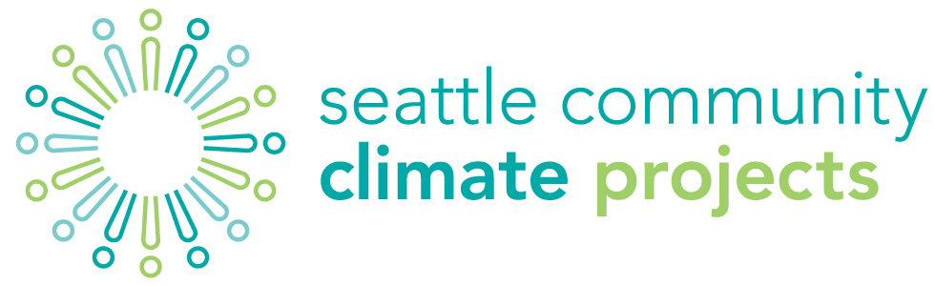
SMall Climate Project Fund

The Small Climate Project fund is open to formal and informal groups year round. Groups must have an annual budget of $25,000 a year or less. Eligible projects are limited to grassroots climate focused programs, events, education or outreach initiatives. Existing annual events are NOT eligible for this funding. Events or programs must be free and open to the public.
Limit one request per organization, per year.
application
Name:
Community Organization:
Address:
 | Phone: |  |  | Email:
Project description —including the connection to
climate action.
Expected outcome(s):
Project timeframe: |  |  | Expected number  of people involved:
Fiscal Sponsor:  (if applicable) |  |  | Contact name  & contact info (phone and email):
The Small Climate Project Fund provides support on a reimbursable basis. Original receipts will be required for all expenses. A short report on your project once it is complete is also expected.
Questions can be directed to Sara Wysocki, sara.wysocki@seattle.gov, 206.233.7014

