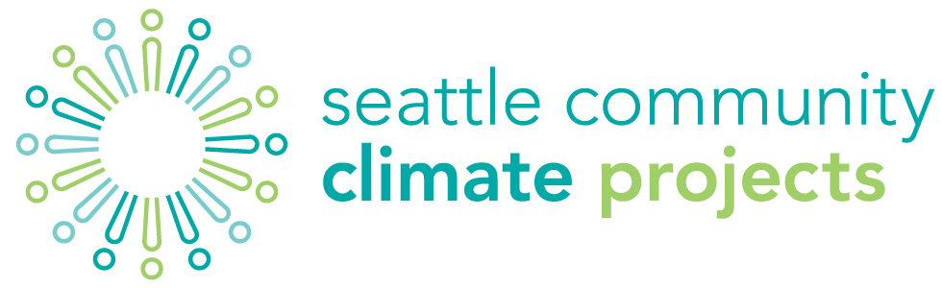
COMMUNITY REVIEWer Application

The Office of Sustainability & Environment welcomes community participation in our review process for the 2014 Community Climate Projects. This is a voluntary position. Community reviewer(s) will be selected via lottery from all qualified applications. Application deadline is 4 pm on Thursday, April 3.
application
Name:
Community organizations
you are affiliated with
(or have been in
the past 3 years):
Address:
 | Phone: |  | Email:
Brief description
of your past community involvement activities:
Brief explanation of your experience or knowledge of
climate issues:
Dates/Times you are unavailable to meet (between April 29
and May 9):
Time commitment will vary depending on the number of applications received, but applicants may safely assume between a 10 and 20 hour commitment. There will be two, 2-hour meetings with a possibility of a third. Community reviewers cannot be affiliated with any organization that is applying for funding and failure to disclose a connection will result in forfeiture of position. By submitting this application, you are acknowledging your acceptance of the conditions and expectations of this role.

