Community Climate Projects: Application

The City of Seattle Office of Sustainability & Environment (OSE) wants to support grassroots organizations that engage the community in climate action. OSE will award contracts of up to $10,000
for projects that address household choices in one of the following areas:
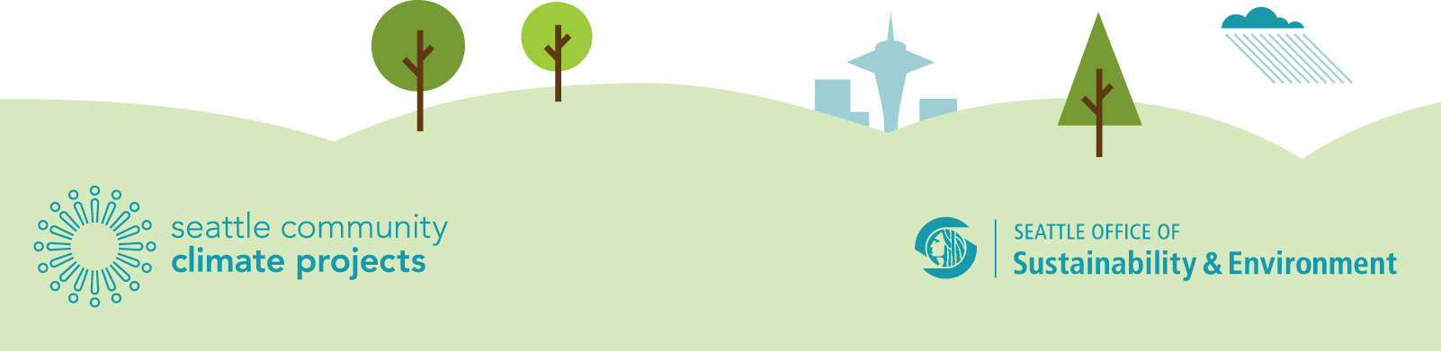
- Home Energy Use
- Getting Around
- Food Choices
- Buying Stuff
- Waste
………………………………………………………………………………………………………………….
Successful proposals will meet the following criteria*:

- Fosters climate-friendly purchasing, transportation or home energy choices and has a clear climate benefit.
- Identifies a clear target audience, objective, outcomes, and a means to measure success
- Engages a diverse community or a historically under-represented population
- Is imaginative, innovative or inspiring
- Builds on community connections
- Potentially sharable or scalable

………………………………………………………………………………………………………………….
How to Apply:

Complete the following form and return it no later than 5:00 pm, April 22 2014.
Email: Sara.Wysocki@seattle.gov
Electronic submissions strongly preferred.
Fax: 206-684-3013
Mail: PO Box 94729, Seattle, WA 98124-4729

Community Climate Projects: Application

Project Name:
 |  |  | Choose a category:
 | Home Energy |  | Getting Around |  | Food Choices |  | Buying Stuff |  | Waste

Lead Organization:
Project Leader:
 |  |  | Phone: |  | Email:
Fiscal Sponsor and contact name
 |  |  | Phone: |  | Email:
Objective, Description, and Rationale
Project idea:
Expected outcome(s):
How will this reduce GHG emissions:
How will you measure your success – specific details required:
Target Audience:
Please be as specific as possible about your proposed audience - including expected number of people involved or reached.
Identified Personal/Household Choices:
Please be as specific as possible about the choices/behaviors you are targeting.
Current Funding:
If this project currently has some funding, how will the additional OSE funding be used?
Proposed Work Plan / Timeline:
Please include work plan that includes tasks, deadlines and parties responsible for identified tasks and deliverables.
Do you see an opportunity to connect this project to existing city programs?
Not a project requirement. However, if you can identify an existing city connection, please explain.
Is the project proposal a new idea or program? If no, please explain.
If this proposal is already an existing project or program, please explain what new elements this funding will help bring to the program.
Budget
Max budget is $10,000. Below is a sample budget only. Double click anywhere on the spreadsheet below to edit. If you prefer, you may submit a budget as an attachment to the application instead of using the spreadsheet below.

Related Projects:
Please describe any prior community based projects you or your group has worked on, including target audience, method and any results available. Maximum 5 descriptive bullets.
Project Lead Signature: |  |  |  |  |  | Date Submitted:

