**DRAFT MEETING NOTES – CAC REVIEW/APPROVAL PENDING**

**Lake Union Village CAC**

December 11, 2018

1. Introductions
   1. Lisa Custaveson, City of Seattle
   2. James Passey, Neighbor
   3. Lindsey Schoenman, Lifelong
   4. Sean Watkins, Lifelong
   5. Shelby Henkel, LiHi
   6. Karen Ko, City of Seattle
   7. Paul Wohnoutka, Allen Institute
   8. Steven Uy, Neighbor- Facebook
   9. John Streimikess, Lifelong
   10. Manpreet Sandhu, Neighbor- GMMB
   11. Michael Schabbing, Neighbor- Courtyard
   12. Carnella, Case Manager
2. Discussion of CAC positions
   1. Chair nominations:
      1. James Passey- Chair for Today
   2. Discussion on Approval of November Meeting Minutes- Approved.
3. Village Management Report
   1. Per Shelby: Village is almost to capacity, there are only 2 empty houses left. 27 residents, 5 couples. Units should be filled by next Monday.
   2. OSL (Operation Sack Lunch) started at the camp and residents are getting 1 hot meal a day. Chore List has been set up.
   3. Thanksgiving Holiday Dinner was catered by Art Marble. Photos from the holiday lunch Included below.*
   4. Christmas dinner:
      1. Residents of LUV have expressed interest in cooking Christmas dinner.

Photos from Thanksgiving lunch:

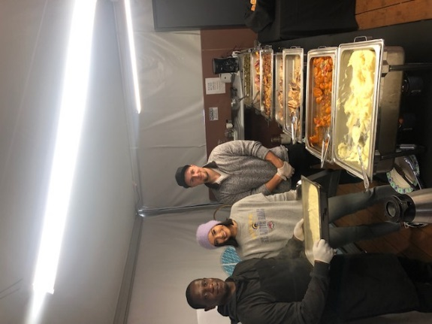 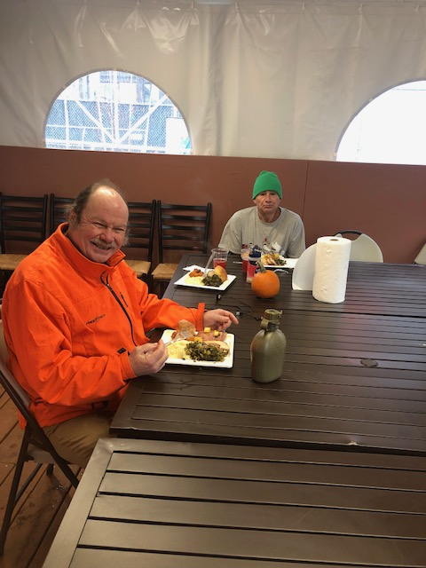

1. Case Management Report
   1. Per Sean: residents of this village are required to engage in case management services. Many residents are not document ready.
   2. 3 Individuals have been referred to more permanent housing since they entered the village through DSCE programs.
   3. Valley Cities has streamlined their referral process for residents coming from the village.
2. Open Discussion
   1. Will there be residents of the village coming to the meeting?
      1. Per Shelby, 2-3 residents have expressed interest in coming in January meeting.
   2. SPD has been on site on a regular basis and we may have an SPD rep coming to one of the CAC meetings as well.
      1. As of this week the SPD West Precinct has received zero complaints/ calls about residents. There have also been zero medic responses. Community members may see an increased police presence since some residents are on probation.
   3. Lawsuit has been filed against LIHI and the city- one of the allegations is there is no management plan. We have received a management plan. We would be happy to email that to everyone.
      1. Lisa will be sharing the service plan with CAC members.
   4. Ebbs and flows on housing placement depending on resources.
      1. Try to be very intentional about housing placement since we don’t want residents to re-enter homelessness.
   5. There are 9 villages currently operating in the city, only 2 operating under the enhanced model with more programmatic structure available to them.
   6. Food donations to the village:
      1. Many local businesses (such as Starbucks) are already donating their excess food. Food Lifeline’s waitlist is full at the moment.
      2. James – will try to make a connection with MetMarket in Queen Anne.
      3. Recommended food donations:
         1. Fresh fruit is something that the village often does not get enough of.
         2. Many people are connected with DSHS and do get their own food and have access to the shared kitchen. Kitchen does have a freezer as well.
         3. Food Access is more of a varietal issue than a scarcity issue.
   7. Furnishing
      1. Towels, blankets, bedding are always welcome. As well as soap and toiletries.
      2. There is a washer/dryer on site.
      3. Fall 2019- Marriot will be remodeling and will have additional items to donate.
   8. Per Michael, whatever you’re doing- keep it up. The camp has been clean and tidy and there have been minimal disruptions to the hotel/community.