Public Notice
June 23, 2017
Regarding City of Seattle Owned Property
Located at: 19031 and 19021 40th Place NE

Dear Neighbor,

The properties located at 19031 and 19021 40th Pl NE will be made available in late June 2017 for purchase through an open and competitive process. This process will include listing of the property with a real estate broker who will market the property to get the maximum exposure with potential buyers. The City has selected James Tjoa & Associates to represent the City in the sale of the property.

This property is being sold following a 2015 public hearing and approval of Ordinance 124936 by Seattle City Council. The City of Seattle has been interested in selling this property for over ten years. During that time, the City of Seattle given the City of Lake Forest Park and a community group time to raise the funds to directly purchase it. The City of Seattle now needs to move forward with an open and competitive sale process.

Purchase inquiries should be directed to James Tjoa & Associates, 2312 Eastlake Ave East, Seattle, WA 98102; (206) 726-6230; info@jamestjoa.com.

If you would like to know more about the City of Seattle property disposition process, or specifics about this property, please contact, Daniel Bretzke, danielbretzke@seattle.gov, 206 733-9882.

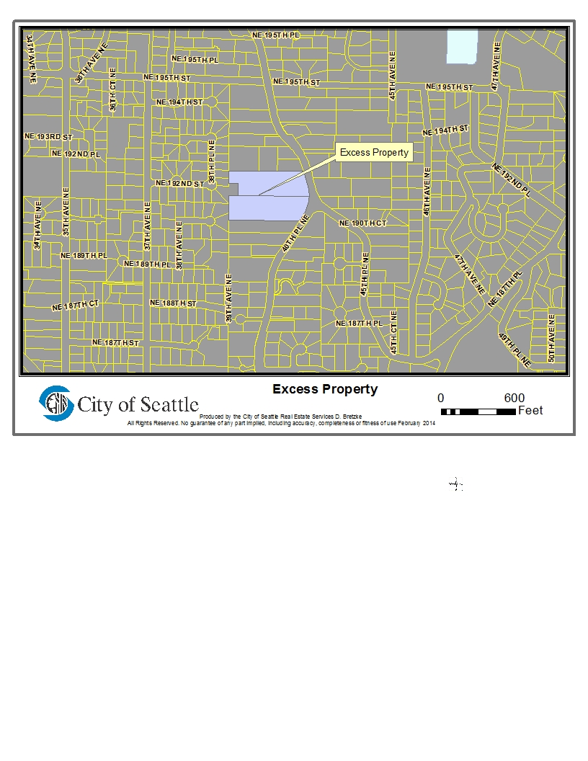
More information about these properties can be found at http://www.seattle.gov/realestate/propertyreview.htm
for
Properties under Seattle Public Utilities Jurisdiction

