EXCESS PROPERTY DESCRIPTION
November 12, 2015

The Department of Finance and Administrative Services, as the Jurisdictional Department of this City owned property has identified the following information about this excess property.

Property Name: JTF Expansion property

PMA | Building Size | Lot Size | Parcels | Address | Zoning | 2015 Est. Value
4601 | Undeveloped lot | 200,255  square feet | 322404-9082 |  | C2- 65 | $2-4 million

Map:

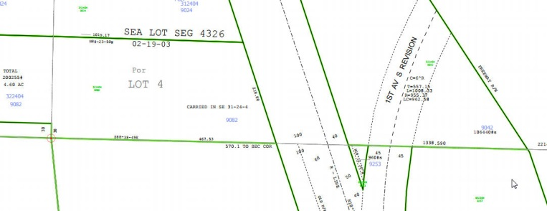
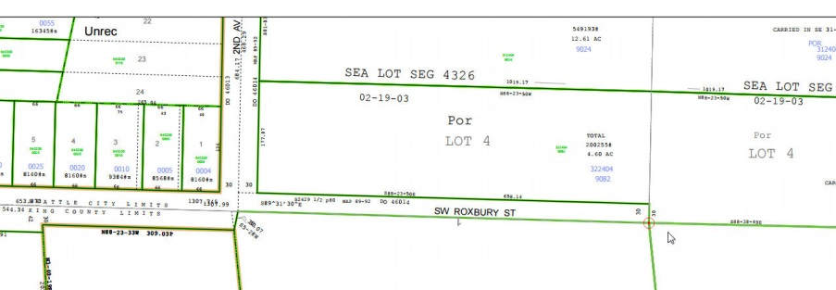

PMA 1656

History: The land known as the Myers Way Properties was purchased as part of a larger parcel in mid-2003 for development of the Joint Training Facility (JTF) at 9401 Myers Way South. In 2006, the Seattle City Council, by ordinance 122308, declared 31 acres of the properties surplus and authorized a sale. The sale transaction was not completed due to environmental and permitting issues. Additionally, the downturn in the local economy negatively affected prospects for a sale. Since this time, the Department of Finance and Administrative Services (FAS) staff have evaluated potential other municipal uses of the property, including a municipal jail, urban farming, support of seawall project, Seattle Public Utilities Drainage operations facility and a Seattle City Light training facility.

The portion of this property is identified as PMA 4601 has been identified by FAS for potential expansion of the Joint Training Facility based upon a request by Seattle Public Utilities and the Seattle Fire Department to use the property for additional training and parking facilities.

Documents:
Detailed environmental studies and reports have been conducted, including a wetland delineation report by Raedeke and Associates and a site constraint map prepared by Goldsmith Engineering. Visit https://opendata.socrata.com/Government/Myers-Way-Properties-Public-Information/v6bs-a4e8 for copies of these and other documents.

Jurisdictional Department’s estimated market value:
FAS has evaluated the value based upon a recent appraisal of the property.

Destination of funds upon transfer: A portion to the Facility Services Sub-fund for expenses relating to sale of property, a portion to repay an interfund loan on the property, and as designated by Council.

Current easements, covenants and restrictions: The site contains some steep slopes and wetlands.

Recommended easements, covenants and restrictions upon Transfer: Covenants regarding existing drainage facilities, wetlands and areas of steep slopes to be recorded as identified through the development review of the property.

Potential problems with property and possible measures to mitigate their recurrence:
On parcel contains steep slopes and the other parcel contains wetlands. If the parcels to the south are sold, the property’s vehicle access is limited due to an existing wetland along Myers way. The parcels would use the existing JTF access to Myers Way.

Neighborhood: West Seattle, Highland Park

Legal Descriptions:

322404-9082 | POR OF SE 1/4 OF SEC 31 & SW 1/4 OF SEC 32 OF 24-04 BEG AT SE COR OF SD SEC 31 TH N 01-06-49 E ALG E LN OF SD SEC 31 FOR 30 FT TO NLY MGN OF SW ROXBURY ST TH N 88-23-50 W ALG SD NLY MGN 624.14 FT TO E MGN OF 2ND AVE SW TH N 01-03-17 E ALG SD E MGN 177.87 FT TH S 88-23-50 E 1019.17 FT TO WLY MGN OF MYERS WAY S TH S 18-17-02 E ALG SD WLY MGN 218.88 FT TO S LN OF SEC 32 TH N 88-38-49 W ALG SD S LN 467.53 FT TO POB BEING LOT 4 OF SEATTLE LOT SEG #4326 DATED 02-19-03

per sf

