EXCESS PROPERTY DESCRIPTION
November 12, 2015

The Department of Finance and Administrative Services, as the Jurisdictional Department of this City owned property has identified the following information about this excess property.

Property Name: Parcels at 9600 Myers Way S

PMA | Building Size | Lot Size | Parcels | Address | Zoning | 2015 Est. Value
4542 | Undeveloped lot | 308,840 Square feet | 052304-9053  052304-9258  052304-9024  052304-9052 | 9600 Myers Way S | C2- 65 | $100,000- $300,000
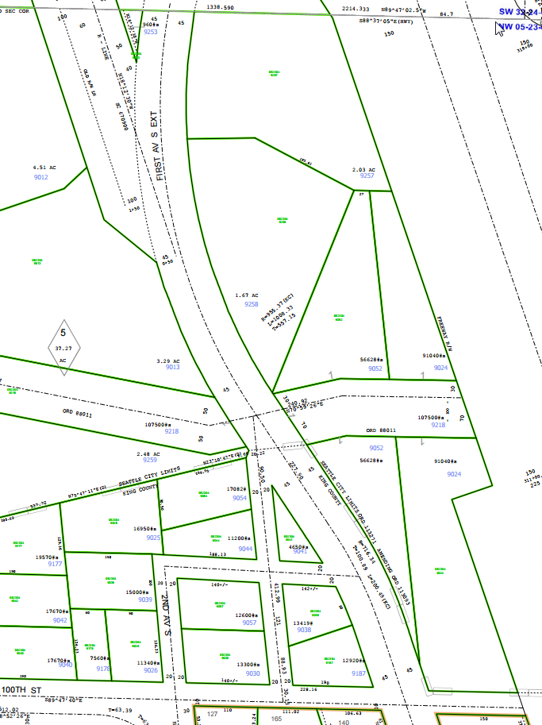
Map:

PMA 1656

History: The land known as the Myers Way Properties was purchased as part of a larger parcel in mid-2003 for development of the Joint Training Facility (JTF) at 9401 Myers Way South. In 2006, the Seattle City Council, by ordinance 122308, declared 31 acres of the properties surplus and authorized a sale. The sale transaction was not completed due to environmental and permitting issues. Additionally, the downturn in the local economy negatively affected prospects for a sale. Since this time, the Department of Finance and Administrative Services (FAS) staff have evaluated potential other municipal uses of the property, including a municipal jail, urban farming, support of seawall project, Seattle Public Utilities Drainage operations facility and a Seattle City Light training facility.

The portion of this property is identified as PMA 4541 has been identified by FAS for potential sale for use by economic development or to be held by the City for future uses and environmental buffers.

Documents:
Detailed environmental studies and reports have been conducted, including a wetland delineation report by Raedeke and Associates and a site constraint map prepared by Goldsmith Engineering. Visit https://opendata.socrata.com/Government/Myers-Way-Properties-Public-Information/v6bs-a4e8 for copies of these and other documents.

Jurisdictional Department’s estimated market value:
FAS has evaluated the value based upon a recent appraisal of the property.

Destination of funds upon sale: A portion to the Facility Services Sub-fund for expenses relating to sale of property, a portion to repay an interfund loan on the property, and as designated by Council.

Current easements, covenants and restrictions:

Recommended easements, covenants and restrictions upon Transfer: Record upon sale of property, storm drainage easements for existing drainage system. Permission to use the SCL right of way for access or other uses such as parking will need approval from Seattle City Light and the Seattle City Council.

Potential problems with property and possible measures to mitigate their recurrence:
The only developable portion of the property is split by the existing Seattle City Light fee owned right of way. Development of the property would be limited to small building pads north and sound of the Seattle City Light Right of Way.

Neighborhood: West Seattle, Highland Park

Legal Descriptions:
0523049257 | POR LYING ELY OF MYERS WAY S OF SD PAR DAF - BEG AT NW COR OF GOV LOT 5 TH S 06-50-52 E 495 FT TH N 70-29-08 E 498 FT TH N 46-29-08 E 125.86 FT TH N 88-15-15 E 244.56 FT TH S 62-56-00 E 195.81 FT TH E 239.9 FT TH TO NE COR OF SD LOT TH W TO BEG LESS CO RD LESS ST HWY
0523049258 | POR LYING ELY OF MYERS WAY S OF PAR DAF - BEG 495 FT S 06-50-52 E OF NW COR OF GL 5 TH N 70-29-08 E 498 FT TH N 46-29-08 E 125.86 FT TH N 88-15-15 E 244.56 FT TH S 62-56-00 E 195.81 FT TH S 22-04-00 W 496.69 FT TH S 74-40-24 W 537.72 FT TH N 66-04-40 W 256.4 FT TO W LN OF GL 5 TH N 06-50-52 W ALG W LN 329.5 FT TO BEG LESS CO RD LESS TRANS LN R/W LESS ST HWY
0523049024 | BEG AT SW COR OF LOT 5 TH S 89-48-48 E ALG S LN 1006.14 FT TO TRUE BEG TH N 05-31-18 W 899.8 FT TH E 266.9 FT TO CENT LN OF CO RD TH S 05-31-18 E ALG CENT LN OF CO RD 760.5 FT TH S 37-43-18 E ALG SD CENT LN 177.89 FT TO S LN OF N 1/2 OF NW 1/4 TH N 89-48-48 W 364.8 FT TO TRUE BEG EX POR IN NE 1/4 OF NW 1/4 & LESS CO RDS LESS TRANS LN R/W LESS ST HWY
0523049052 | BEG 1005.73 FT E OF SW COR GL 5 TH N 05-30-14 W TO NXN WITH E LN OF 1ST AVE S EXT RD & TRUE BEG TH N 05-30-14 W TO A PT 899.85 FT NLY OF S LN OF SD GL TH W 27 FT TH S 22-04-00 W TO E LN SD 1ST AVE S EXT TH FOLG SD LN SLY TO TRUE BEG LESS TRANS LN R/W

