EXCESS PROPERTY DESCRIPTION
November 12, 2015

The Department of Finance and Administrative Services, as the Jurisdictional Department of this City owned property has identified the following information about this excess property.

Property Name: Parcels at 9501 Myers Way S

PMA | Building Size | Lot Size | Parcel # | Address | Zoning | 2015 Est. Value
4540 | Undeveloped lot | 713,123 square feet | 0623049001  0523049012  0523049013 | 9501 Myers Way S | C2- 65 | $12-15 million

Map:

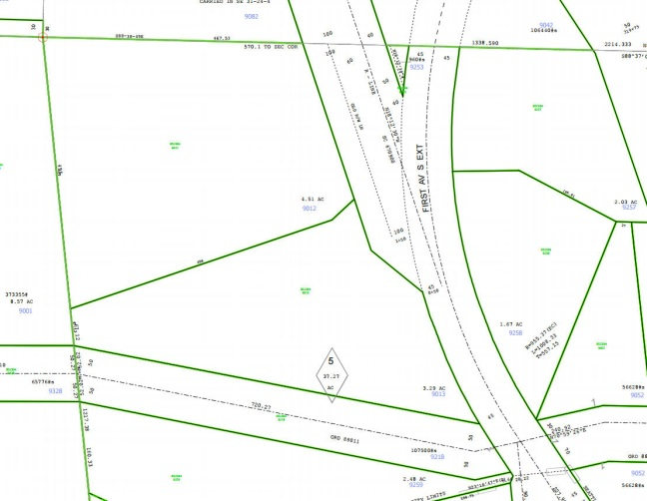
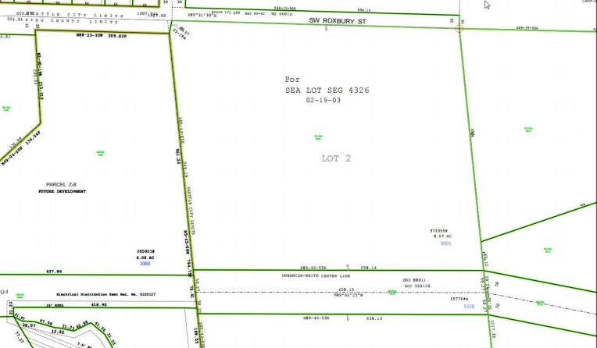

PMA 1656

History: The land known as the Myers Way Properties was purchased as part of a larger parcel in mid-2003 for development of the Joint Training Facility (JTF) at 9401 Myers Way South. In 2006, the Seattle City Council, by ordinance 122308, declared 31 acres of the properties surplus and authorized a sale. The sale transaction was not completed due to environmental and permitting issues. Additionally, the downturn in the local economy negatively affected prospects for a sale. Since this time, the Department of Finance and Administrative Services (FAS) staff have evaluated potential other municipal uses of the property, including a municipal jail, urban farming, support of seawall project, Seattle Public Utilities Drainage operations facility and a Seattle City Light training facility.

The portion of this property is identified as PMA 4540 has been identified by FAS for potential sale for use by economic development.

Documents:
Detailed environmental studies and reports have been conducted, including a wetland delineation report by Raedeke and Associates and a site constraint map prepared by Goldsmith Engineering. Visit https://opendata.socrata.com/Government/Myers-Way-Properties-Public-Information/v6bs-a4e8 for copies of these and other documents.

Jurisdictional Department’s estimated market value:
FAS has evaluated the value based upon a recent appraisal of the property.

Destination of funds upon sale: A portion to the Facility Services Sub-fund for expenses relating to sale of property, a portion to repay an interfund loan on the property, and as designated by Council.

Current easements, covenants and restrictions: Seattle City light has an easement over a small portion of the parcel adjacent to the transmission right of way located along the southern boundary of parcel number 052304-4903.

Recommended easements, covenants and restrictions upon Transfer: Record upon sale, storm drainage easements for existing drainage system over the parcels.

Potential problems with property and possible measures to mitigate their recurrence: A portion of the property has been identified as having buried cement kiln dust that contains some arsenic and lead. Ground water monitoring wells have been installed, and a phase II environmental report has been completed. Strategies on clean up or containment are yet to be identified.

Neighborhood: West Seattle, Highland Park

Legal Descriptions:

0623049001 | POR OF NE 1/4 BEG AT NE COR OF SEC 6 TH N 88-23-50 W ALG N LN OF SD SEC 654.11 FT TH S 05-28-00 W 30.07 FT TH S 05-44-05 E ALG E LN 548.19 FT TO NLY LN OF TRAN LN R/W TH S 89-46-53 E ALG SD NLY LN 658.14 FT TO E LN OF SD SEC TH N 05-44-05 W ALG SD E LN 562.41 FT TO TPOB BEING LOT 2 OF SEATTLE LOT SEG #4326 DATED 02-19-03
0523049012 | POR LYING WLY OF ST RD OF SD PAR DAF - BEG AT NW COR OF GOV LOT 5 TH S 06-50-52 E 495 FT TH N 70-29-08 E 498 FT TH N 46-29-08 E 125.86 FT TH N 88-15-15 E 244.56 FT TH S 62-56-00 E 195.81 FT TH E 293.9 FT TH TO NE COR OF SD LOT TH W TO BEG LESS CO RD LESS ST HWY
0523049013 | POR LYING WLY OF MYERS WAY S & NLY OF TRANS LN OF PAR DAF - BEG 495 FT S 06-50-52 E OF NW COR OF GL 5 TH N 70-29-08 E 498 FT TH N 46-29-08 E 125.86 FT TH N 88-15-15 E 244.56 FT TH S 62-56-00 E 195.81 FT TH S 22-04-00 W 496.69 FT TH S 74-40-24 W 537.72 FT TH N 66-04-40 W 256.4 FT TO W LN OF GL 5 TH N06-50-52 W ALG W LN 329.5 FT TO BEG LESS CO RD LESS TRANS LN R/W LESS ST HWY

Adjacent Property Owners:

9368700126 9368700106
Edmon, Elisha E. Tran Truong Nhat
5515 S. Bangor St. 10617 56th Ave S.
Seattle, WA 98178 Seattle, WA 98178
Land value: $71,00 $12.6 per sf Land value: $78,000, $10.83 per sf

9368700112 9368700108
Cormier, Donald J. Nguyen, Hoa
5519 S. Bangor St. 10621 56th Ave S.
Seattle, WA 98178 Seattle, WA 98178
Land value: $66,000, $12.22 per sf Land Value: $88,000, $8.49 per sf

9368700110 9368700127
Winstead, Raymond H. Jr. + Makeb Bushnell, Roger G.
5521 S. Bangor St. 10616 55th Ave S.
Seattle, WA 98178 Seattle, WA 98178
Land Value: 64,000, $14.50 per sf Land Value: $74,000, $11.76 per sf
9368700135 9368700128
Pratt, Mitchell-Roberta Murray, Jacqueline
5516 S. Hazel St. 10610 55th Ave S.
Seattle, WA 98178 Seattle, WA 98178
Land value: $89,000, $7.26 pef sf. Land value $71,00, $12.6 per sf

936870 0131 9368700130
Morningstar, Sarah Emerald Real Estate Solution
5503 S Bangor St 5507 S Bangor St
Seattle, WA 98178 Seattle, WA 98178
Land value: $56,00, $12,93 per sf Land value: $ 67,00 $14.50 per sf

