EXCESS PROPERTY DESCRIPTION
November 12, 2015

The Department of Finance and Administrative Services, as the Jurisdictional Department of this City owned property has identified the following information about this excess property.

Property Name: Parcel at 9403 2nd Ave SW

PMA | Building Size | Lot Size | Parcels | Address | Zoning | 2015 Est. Value
4539 | Undeveloped lot | 97,646 Square Feet | 645330-0010 | 9403 2nd Ave SW | C1- 65 | $50,000- $100,000

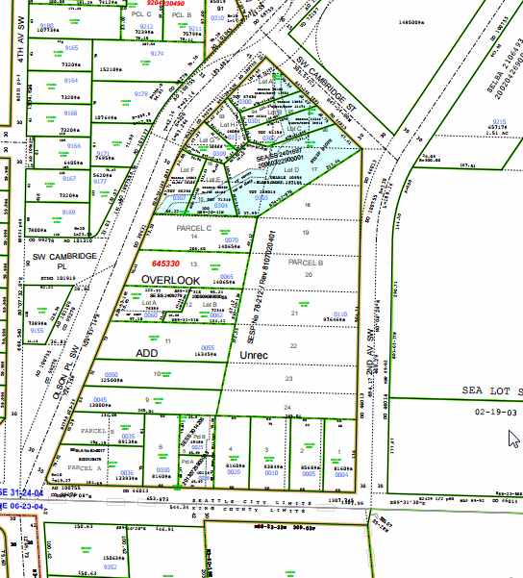
Map:

PMA 1656

History: The land known as the Myers Way Properties was purchased as part of a larger parcel in mid-2003 for development of the Joint Training Facility (JTF) at 9401 Myers Way South. In 2006, the Seattle City Council, by ordinance 122308, declared 31 acres of the properties surplus and authorized a sale. The sale transaction was not completed due to environmental and permitting issues. Additionally, the downturn in the local economy negatively affected prospects for a sale. Since this time, the Department of Finance and Administrative Services (FAS) staff have evaluated potential other municipal uses of the property, including a municipal jail, urban farming, support of seawall project, Seattle Public Utilities Drainage operations facility and a Seattle City Light training facility.

The portion of this property is identified as PMA 4539 has been identified by FAS to be held by the City for future uses and environmental buffers to the Joint Training Facility.

Documents:
Detailed environmental studies and reports have been conducted, including a wetland delineation report by Raedeke and Associates and a site constraint map prepared by Goldsmith Engineering. Visit https://opendata.socrata.com/Government/Myers-Way-Properties-Public-Information/v6bs-a4e8 for copies of these and other documents.

Jurisdictional Department’s estimated market value:
FAS has evaluated the value based upon a recent appraisal of the adjacent property.

Current easements, covenants and restrictions: None

Recommended easements, covenants and restrictions upon Transfer: Not to be transferred.

Potential problems with property and possible measures to mitigate their recurrence:
The property contains steep slopes and wetlands.

Neighborhood: West Seattle, Highland Park

Legal Description:
6453300110 | OVERLOOK UNREC PAR B CITY OF SEATTLE SP 78-212 REC #7901020608 REV'D UND REC #8107020401 SD SP DAF ALL LOTS 14 THRU 24 & 93 THRU 96 TGW VAC ST ADJ LESS POR FOR ST

